Welcome to
Baylor College of Medicine’s
Pediatric Residency Program!

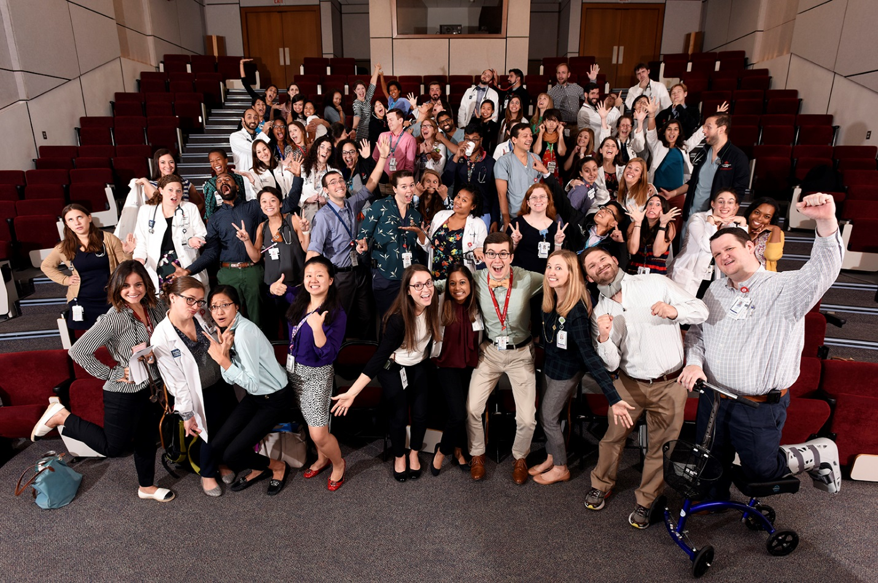

An Intern’s Guide to Houston 2018-2019
Table of Contents:

Welcome & Introduction 3
Time Management/ Tips for Call Months 4
Dealing with the Stress of Residency 5
Some More Advice 7
Where to Buy a White Coat 9
Studying & Reading 10
Taking the USMLE Step 3 11
Getting Your TX Medical License 11
Becoming a Licensed Texas Driver 12
First Steps to Personal Finance 13
Banks 18
Child Care 19
Dental Care 22
Physicians 23
Pets 25
Churches & Places of Worship 27
Exercising & Gyms 30
Tailors & Dry Cleaning 32
Haircuts / Salons 33
Auto Repair 34
A/C Repair & Plumbers 35
Recycle 35
Shopping 37
Special Recommendations 39
Our Favorite Things to Enjoy Around Houston 39
House Staff Events Book 41
Houston Radio Stations 42
Our Favorite restaurants 43
Happy Hours 53
Places to Study/ Coffee/ Tea shops 54
Ice Cream 55
Places that Deliver Food to the Medical Center 55
BCM Employee Benefits 56
Come Visit the House Staff Office Often 57
Meet your Associate Program Directors 58
Helpful Websites... 59

Welcome & Introduction

Welcome to the Baylor Pediatrics Family! We are looking forward to meeting you and working closely with all of you over the next year.

As you await the beginning of your internship, we want to share with you the “2018-2019 Baylor Pediatrics Intern Guide”. The “Baylor Pediatrics Intern Guide” was started by the chief residents a few years ago and serves as a resource for incoming residents. It offers valuable information such as rotation tips from upper levels and insider information about places to live, eat, and relax. We hope this guide helps prepare you for the upcoming year while offering you insight into the true spirit of community and camaraderie here at Baylor.

We have treasured our time in residency and look forward to serving you as chief residents! Welcome!

The Chiefs,
Nicolle, Kim, Taylor, and Flora

Time Management & Tips for Call Months
Chapter 1: On the Wards

Develop a system for staying organized early in intern year and stick with it. Be systemic about the way you organize information about patients, synthesize data, and implement a plan. Try to think two steps ahead in the plan to anticipate when patients will be discharged, and begin your discharge summaries as far in advance as possible (for some patients, this means right after you complete your H&P!).

Keep a calendar with your work schedule and all meetings and appointments. You can import the call schedule from Amion into your calendar application (for Mac users). Use the same calendar for all of your meetings and personal obligations, and use the reminder feature on your calendar to alert you in advance for upcoming events so you won’t forget.

When you are on the floors, make sure to batch your work whenever possible. Do similar jobs together- i.e. look at all labs at the same time, batch your progress notes and sign them all at the same time, etc.


When you are on call/ doing cross-cover duties, do all you can at one end of the hall before moving…

Keep updated to-do lists and stay organized! Organize your on call to-do list on a paper that lists times along the side, and organize check-out accordingly (there are templates you can use to stay organized on call!). Use the “Time Mark” feature (found on the tool bar at the top of the page) to keep track of new labs while on call or working overnight.

Chapter 2: At Home
- Do as many errands and household chores during the week so that your day off is protected.
- Save time - shop online! (Amazon may become your new best friend or take advantage of HEB Curbside and other grocery delivery services!)
- Buy the largest amount of paper towels and bath tissue that can fit in your place of dwelling
- Stock up on frozen dinners or consider meal delivery services like Blue Apron or Sun Basket
- Buy Ziploc containers and make meals that yield leftovers
- Whenever you order take-out or pizza, buy extra for leftovers!
- Put take-out numbers in your cell phone or get apps like Door Dash or Uber Eats so you can call when you leave work and then pick up the order on the way or have it delivered to you at home.
- Buy a lot of granola bars and other portable snacks
Dealing with the Stress of Residency
We asked everyone to reveal their secret methods of dealing with the stress of residency:
- Go out to breakfast post-nights with friends

- Plan ahead to do something fun on your day off–don’t let the day take you by surprise to find that you have nothing to do. Otherwise you will sit on the couch and never leave your pajamas (which is ok too sometimes).
- Margaritas! Kidding, sort of…
- Talk with other residents, talk to parents, and use my friends and my family as my therapists
- Exercise even when you are tired – endorphins are a wonderful thing.
- Sleep
- Get a massage
- Spending time with my community- church and friends
- Attend sporting events or arts activities with tickets you won from the house staff office.
- Run outside in the sunshine
- Keep personal lives going outside of residency! Keep doing what you like (even if you do it a bit less than you did before!)

- Play sand volleyball and other organized sports with your co-residents!
- Exercise every non-call day, check out classpass.com
- Try not to bring work home as much as possible
- Make time to keep in touch with your friends (including your non-residency friends!!)
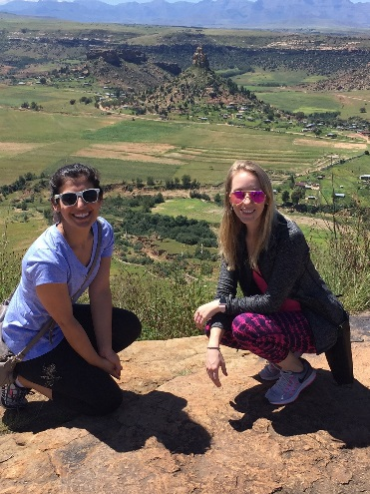
- My dog helps a lot; I strongly recommend a pet companion, especially if living alone, even as an intern. I had my dog as an intern and it can totally be done. There are a lot of people to help out!
- Get out of town for a day or two (Austin, Hill Country, etc.)
- Find a hobby (I picked up crocheting!)
- At least a couple times a month when you are post call, stay awake and enjoy your hobby
- Play in the Doctor’s Orchestra! www.tmcorchestra.org
- Leave Houston on your vacations
- Don’t listen to old docs telling you they walked uphill both ways and worked 40 hour days and liked it. You are taking care of the sickest children in history using technology and medicines that they never would have imagined!
- Play a round of Golf at Memorial Park or Hermann Park! Or kick it up a notch at Top Golf!
- Go out with your non-medical friends
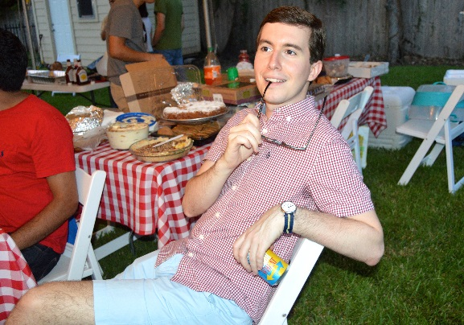
- Remember why you are doing this
- Laugh!
- Talk to your upper levels-they have done this before (and survived)!
- Do things outside (and if it’s too hot, check out some indoor rock climbing)
- But if none of these are working, do not be afraid to look for professional help/ therapy as well- there is nothing wrong with needing a little boost every now and then. I recommend making use of those free counseling session offered through Baylor- I did that as a medical student and it was really helpful. (can view this after you receive BCM Log-on information) https://intranet.bcm.tmc.edu/?tmp=/gme/counseling/psychiatric

Some More Good Advice
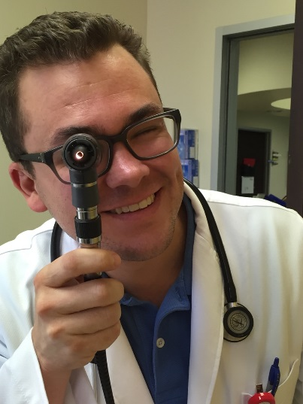
- Relax and have fun as much as possible on your day off—don’t get caught up in laundry/ cleaning/ chores on your days off.
- Ask every patient you admit to TCH, especially the ones with interesting diagnoses, how he/she INITIALLY presented.
- Take ownership of your patients.
- Walk to codes- in the few extra seconds it takes to get there (not enough to kill the patient), find the patient’s information on your list, envision what might be going wrong with him or her, read through your code card, and enter the room calm and confident of what needs to be done (help will be on the way).
- Start a Roth IRA instead of the 403(b) that Baylor offers because Baylor gives no match and you would rather pay taxes now.
- Shorten your commute or if not possible, listen to an audiobook or podcast.
- Take time for yourself and family. Remember your family is here to stay so don’t forget about them even during the craziness of the hospital.
- Remember to learn something new every day. Stay humble. Have fun.
- Cheap museum of art membership if you sign up with somebody else (“couple” membership, although they won’t ask if you sign up with your best friend!)
- Just remember when you are on call- “The morning will always come. It is just a matter of time.”
- Be proactive about learning – don’t be afraid to ask, “Why” to your fellows- it is easy to get lost in the day-to-day work and forget to actually learn, particularly at such a large program. But it can be done- just takes some more effort.
- There is never a stupid question as an intern- that is a luxury- use it!
- Keep the big picture in mind as you’re going through all the details of the day-to –day of intern year…you’re a doctor and have the privilege of taking care of amazing kids! Enjoy it!
- Keep a small notebook in your white coat to write down things you learn from rounds, lectures, etc.
- Exercise makes you feel much better, even if it’s only 10-15 minutes. Take a walk with a friend.
- Stuck in traffic? Long drive back from clinic? Call a friend or family member and stay in touch.
- Post-call nap is a great time to put leave-in deep conditioner on your hair.
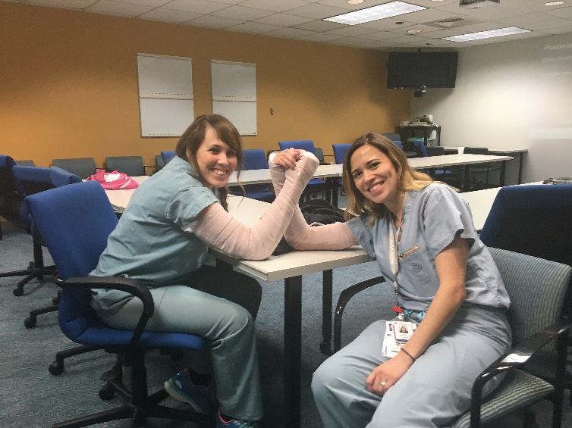
- When you are post-nights or post-call, take a minute to get a delicious breakfast at the Pavilion – oatmeal, breakfast tacos, coffee!
Where to Buy a White Coat
White coats are not provided by the program because they are not a requirement. You will notice a variety of personal preferences when it comes to the white coat. Some residents wear one every day and some never wear a white coat. It is up to you.

Allheart.com
Amazon: PGY-2 girls recommend https://www.amazon.com/ICU-Barco-Womens-Pocket-Princess/dp/B00INX1LL8
Fannin Discount Uniforms: 7131 Fannin (note- all sales final.)
UTHSCH Bookstore: 6431 Fannin, (713)500-5861
Stitches & Such: 2371 Rice Blvd, (713) 524-2339. “You can buy your coats and have them embroidered in the same place. They also have the BCM and TCH logos if you want this on your coat.”
Also, many people buy their coats online! Here is one such website: www.medicalcoats.com (has coats with inside pockets!)

The writing on the jacket should look similar to:
Taylor McLain, M.D.
Pediatrics
(Or it could read Baylor Pediatrics- this is just based on preference)
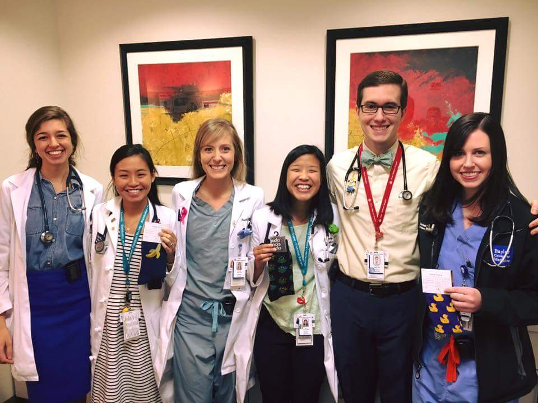
This will go above the pocket on the left side of the coat. Most choose blue or black as a font. Also, some choose to write “Pediatrics” in different bright colors. This is an additional cost. Feel free to ask the chiefs or your upper levels what their white coat looks like.
Studying and Reading

Boo… Hiss… I’m working 80 hours a week and you want me to read too??

Yes. Granted, it will be challenging to read on some rotations, but there are some easier months. Having a good fund of knowledge makes call nights better, and then there’s the added bonus of passing the boards!

If possible, it can be helpful to look up or print out applicable PedsinReview articles prior to the start of a new rotation. For example, prior to starting Hematology/Oncology, print out and read the articles on Sickle Cell, AML and ALL.

You will have access to PedsinReview through your AAP membership that is provided by the program throughout your residency.

Keep a folder in your bag to keep handouts or articles that are distributed. Keep an accordion file (or electronic file) at home to keep good articles. You will be an upper level and teacher one day!

Specific Study Guide Suggestions: Ask your upper levels if they will sell you their study guides.

For Step 3: First Aid for USMLE Step 3, Crush Step 3: The Ultimate USMLE Step 3 Review, www.usmleworld.com, Exam Master: www.library.tmc.edu > Exam Master > Step 3

For the Pediatric Boards: PREP Binder materials and corresponding Peds in Review articles: www.pedialink.org > Resident Center > Training Tools > Pass My Boards

Med Study Products (www.medstudy.com), study pictures in Zitelli’s Atlas of Pediatric Physical Diagnosis, Laughing Your Way to Passing the Pediatric Boards.

Some residents like to purchase MedStudy during their 2nd year and use it through out their rotations. Others chose to wait until the beginning of 3rd year to purchase board prep materials.

Taking the USMLE Step 3

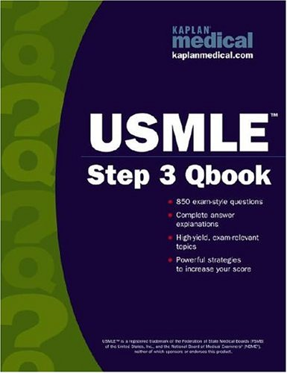
Step 3 is offered throughout the year. In general, taking the USMLE earlier in residency is best. Completing the test prior to the end of second year is optimal, as it is required to begin the state licensure process that can take several months. As of February 2018, the cost of USMLE Step 3 is $850.00. For more information go to: www.fsmb.org/m_usmlestep3.html

Getting your TX Medical License (FYI – you will hear a lot more about this during your 2nd and 3rd year):

Refer to the SharePoint site on the TCH Intranet (after you receive TCH computer access) and view the post residency folder. View the document, “how to obtain your medical license.” This document was started by a former resident and is periodically updated. Please be advised that applying for license in the state of Texas takes anywhere from 6-9 months and requires that you have completed USMLE step 3. It is highly recommended to begin your application EARLY in your third year so that you are licensed by graduation. As of February 2018, the total cost for applying was over $3,000. This includes your DEA registration. Keep this in mind when you are planning your time, especially as the American Board of Pediatrics requires you have your license prior to sitting for your Pedi Boards! For more information, go to www.tmb.state.tx.us.

Becoming a Licensed Texas Driver

In Texas, the process of registering a vehicle, changing the title and obtaining a new driver’s license, is a bit complicated. You must obtain your new car registration and driver’s license within 90 days of becoming a Texas resident.

You can obtain your license at any DMV in Texas. But if you're visiting a small town with a shorter line, do it there! There are 2 DMV “Mega Centers” in Houston where you can get in line, online as soon as the DMV opens for business that day. You will receive text message alerts about your position in line. You can reply to the text message to request an additional 15 minutes if you are running late, but you will not be bumped to the end of the line. Get in line, online: https://www.txdps.state.tx.us/DriverLicense/getinlinebeforeyougo.htm

Step 1: Obtain insurance for your car or update the demographic information with your current auto insurance company to reflect your new state and address.

Step 2: Have your car inspected- safety and emissions. Take proof of insurance with you.
- Firestone Complete Autocare 5719 Kirby Dr, Houston, TX 77005
- Conoco Station 1220 Old Spanish Trail- corner of OST and Kirby
- Texaco Service Center 7901 South Main Street- corner of Main and Kirby
- Midas Holcombe Auto Service- 2407 W. Holcombe- 713-666-4267
- Jiffy Lube 2001 S. Shepard Dr. 713-526-1090
- Almost any auto shop and some gas stations

Step 3: Obtain your new vehicle registration (you must have your car inspected prior to registration).
- Harris County Tax Assessor’s Office
  - 6000 Chimney Rock (SW Houston)
  - 1001 Preston (Downtown)
  - Both locations open 8:00am- 4:30 M-F
  - 713-368-2000

Bring your original out-of-state title, proof of insurance and car inspection along with the odometer reading with you. Bring check book or cash for registration fees. No credit cards accepted. For more information, go to tmv.gov/motorists/new-to-texas. There is a Form 130-U that first time registrants need to fill out that is available on this website.

Step 4: Obtain your new Texas Driver’s License
- DMV Offices
  - 4545 Dacoma, 713-683-0541 (NE Houston)
  - 12220 South Gessner (SW Houston)

Take your out-of-state driver’s license, proof of identity (passport- if you don’t have a passport look online to check other acceptable forms of ID), proof of social security, car registration, and proof of insurance. You will (again) need to wait in line and pay the registration fees.
First Step to Personal Finance
For some of us, this is the first time we are receiving regular paychecks or the first time we can really start saving for retirement. What do you do? Which retirement account is best? Do you know how to pick a fund? What if you are in debt? What follows is just a bunch of accumulated knowledge from other residents. Not professional advice, although we think it is pretty good. So….do your homework, and if you buy or sell anything based on what you read here, you are on your own.

Budgeting:
Believe it or not, you can live on a resident’s salary; all it takes is some careful budgeting. Creating a budget, while scary and certainly not fun, is not as hard as it sounds. Write down your monthly income and subtract all your monthly expenses.

If you are in the negative, re-evaluate your expenses. Are there places you can trim? I mean you don’t need money for fun, right? Aren’t you in residency? Just kidding... If you have extra, this is the amount you can put in savings each month or use to pay down debt.

Remember, there are several expenses unique to residency like Step 3 (1st year), licensing fees (2nd-3rd year), and interviewing expenses (2nd-3rd year). Plan ahead for these big ticket items and save accordingly.

Taxes:
A special word about taxes: The IRS will want their money, and this will affect the amount you have to pay in April. In fact, several of the 2nd and 3rd year residents find themselves owing extra to Uncle Sam every year (and it can be over $1,000…) You should strongly consider taking the least number of allowances possible on your W4 until you know how much you will have to pay in taxes. None of us like giving 0% interest loans to the IRS, but we REALLY don’t like paying extra taxes come April either. The IRS has a withholding calculator that can help you determine how much to withhold: http://www.irs.gov/individuals/index.html.

Goals:
Debt:
Credit Card Debt: the Worst of the Worst. This absolutely must go first. Pick your card with the highest interest rate and pay it off first. Move to the next highest and continue. Make this a priority. Decide how much you can pay each month, and pay it as soon as you receive your paycheck. Don’t wait till the end of the month to see how much you have left. Once they are paid off, do not close the account otherwise your FICO score will go down.
Student Debt: Since they fixed interest rates for Stafford loans in 2006, consolidation is now a much different issue. You may want to consolidate for various reasons: you still have variable rate loans, ease of one bill per month, lower monthly payments, longer term for repayment, and borrower incentives (.025% reduction for direct deposit for example). There are several companies that can consolidate your student debt. Beware of any company that charges for this service. There are NO fees associated with consolidating government loans. Note: Government loans cannot be consolidated with private loans.
If you have paid off all your credit card debt, strongly consider paying off any private high interest student debt next. Yes, most student debt interest is tax deductible up to $2,000, but hanging onto debt is rarely worth the tax savings. Some private loans are not tax deductible.

You can visit https://studentloans.gov to explore income based repayment plans which can SIGNIFICANTLY decrease your monthly loan expenses while in residency/fellowship or deferment/forbearance options. Keep in mind that ultimately you may end up paying more interest with these options, but they can certainly take the pressure off your current budget.

Deferment vs. Forbearance: In deferment you do not make any payments on your student debt. However, the interest still accrues on your unsubsidized loans. This interest will be added to your principal unless you choose to pay it. In forbearance you and your lender can arrange lower payments or temporary cessation of payments. The interest still accrues during forbearance on all subsidized and unsubsidized loans. Don’t forget that you must reapply every year, and you may only defer for 3 years. The GME office can assist you with making these arrangements. Most residents will qualify for deferment under the “economic hardship” provision.
Note: Congress has considered getting rid of economic hardship pathway. The AMA is lobbying to keep it in place unchanged. You might want to keep up with changes as it gets closer to deferment/ forbearance time. You can also contact your representative of the AMA to have your voice heard.
- Emergency Fund: Granted, as a resident you are not very likely to lose your job, but what happens if you get sick, your car breaks down, your spouse loses their job, the TMB wants $3,000 for licensing and fees? You need a small stash of money for, you guessed it, emergencies. Experts say you should have 3-6 months of expenses in an emergency fund. Let’s just start small. If you can pocket away $1,000, that’s a good start. Add to this regularly and you will be surprised how it adds up. Emergency funds need to be in a savings account that you can access quickly. (That’s the emergency part coming back again). High interest savings accounts are ideal for your emergency fund. WTDirect, ING, and Emigrant Direct all have good interest rates with good online security. There are other online banks with good rates as well.

- Insurance: As much as we all hate paying for insurance, it is something we truly need. Luckily, Baylor does provide us with some basic life and disability insurance, which is detailed on the https://intranet.bcm.edu, after you start, under Human Resources > Benefits. You may also buy supplemental insurance through Baylor. Take a look and decide if your situation warrants more insurance. For example, if you have children you m ay consider buying extra term life insurance. Talk to you insurance company if you want extra insurance outside of Baylor. Term life insurance is the best/cheapest option. Variable life is only good for investment purposes and carries a high commission for the salesperson. Watch out for insurance people only interested in selling only variable life.

- Retirement: You are young right? Why do you need to worry about retirement, especially when your future income will far outstrip what you are earning now? The reality is that most people drastically underestimate what they will need for retirement. Throw in the fact that we will get little, if any social security and you really have an uphill battle in front of you. These first years of investing can be your most productive due to compounding interest. Compound interest is the concept of adding accumulated interest back to the principal, so that interest is earned on principal + interest from that moment on. Even a few years of compound interest makes a HUGE difference in the worth of your portfolio. There are several online calculators that can show you the effect of compounding interest. Take a look- it is likely worth it to you to start now.

Types of Retirement Accounts:
Pre-Tax Accounts:
403B- A 403B is the not-for-profit equivalent to a 401K and is the type of account offered by Baylor. You may choose either Fidelity or TIAA-CREF mutual funds to include in your 403B, but not both. Pre-tax contributions are made to your 403B directly from your paycheck and can be invested in any type of fund you choose. You choose how much is taken from each paycheck and into which funds. Contribution limit for 403B accounts is $17,500. By putting pre-tax money in your 403B, you are decreasing your taxable income for the current tax year, thus saving money now. You pay taxes when you withdraw the money, so you will pay taxes dependent on the tax bracket you will be in at retirement. The benefit is for those who will be in a lower tax bracket when they retire, thus saving money overall. (Keep in mind that tax brackets can and often are changed by the government, plus you may not be in a lower tax bracket when you retire.) That being said, 403B accounts are a great way to start saving as it is a form of forced savings.
Post-Tax Accounts
Roth IRA- You may put post-tax dollars (i.e. what you take home) in a Roth IRA. $5,000 is the contribution limit. Since you set up the account yourself, you can put your money in any fund/stock/bond you choose. The money then grows tax free (because the taxes were already taken out), and you are not taxed on withdrawals as long as you are least 59½ years old. Any original contributions can be withdrawn at any time without penalty. Thus a Roth can serve both as a retirement account and as an emergency fund of sorts. Frankly these are great accounts and can be set up at any brokerage firm (Fidelity, TIAA-CREF, Vanguard, etc.). You especially may want to consider this type of fund since you likely will not be able to contribute for long. The income limit is $114,000 for single filers and $169,000 for joint filers. Residency/ fellowship years may be your only opportunity to take advantage of this type of account, so think about it.
A Roth IRA is likely the better choice for residents who are single or have a non-working partner, with the assumption that your tax bracket will be higher at retirement than it is when you are making 50 some thousand as a resident.
What type of fund should I put in my account?
Granted everyone has their own style and opinion, but there are a few basic guidelines to choosing a mutual fund.
- Stock vs. bond funds- you are young enough that any retirement money should be mostly stock funds. Stocks are riskier than bonds, so it is a matter of personal comfort how much risk you are willing to take. Historically the risk is minimal when investing for 20-30 years.

- Asset Allocations- when building a portfolio you must diversify to reduce risk. (Enron anyone?) Try to pick funds that cover a wide variety of companies. Large blend funds are excellent choices for stable core funds. Unless you already have a portfolio built, this is not the time to invest in emerging markets.

- Fees- all mutual funds charge a fee for general maintenance. Ideally this should be less than 1% and absolutely less than 1.5%. Higher fees can really eat into your future returns. Never buy a loaded fund.

- Past Performance- look at a fund’s performance over the past 5-10 years. This will give you a good idea of how the fund will do in the future.

The beginning investor should consider two special types of funds, index funds and target date funds. Index funds are set to mirror the stock market. If the market goes up, so does your fund. These funds have built in diversity and their low fees make them hard to beat in the long run. Target date funds are also new on the scene, but are great way to get in on the action. They are designed to automatically get more conservative (more bond funds) as you get closer to retirement. Not all target date funds are created equal, so be sure to look at the individual fund’s past performance.
If you want to learn more about specific funds, or personal finance in general, www.morningstar.com and www.kiplinger.com are both excellent online options. TIAA-CREF also has funds/ portfolios already pre-designed, and you may pick a selection that matches “Retirement in 2040” for example.
How to create your 403 with Baylor
- Go to www.bcm.edu > Intranet > Human Resources > Benefits
- Click on “Retirement and Retirement Plans Account Access”
- Under “Instructions for Enrolling or Making Changes to a 403B Tax Deferred Plan” there are detailed instructions on how to create your 403B. You will be asked which company you would like to invest with (Fidelity or TIAA-CREF), how much you would like to invest per paycheck in percentage, and which funds you would like to invest in. You may change your contributions at any time. You may also change how those contributions are divided among your chosen funds. Expect a delay of a paycheck or two before the changes take effect.
Do you have questions or want to talk to someone about personal finance?
Contact BCM Fidelity: 1-800-343-0860
Ben Pfeffer (Keller Williams Realty) is a highly recommended realtor who will even interview and find you a realtor when you move after graduation.
5050 Westheimer Rd. Houston, TX 77056 C: 281-658-5816 O: 713-513-6874
E: ben@bensellshouston.com>

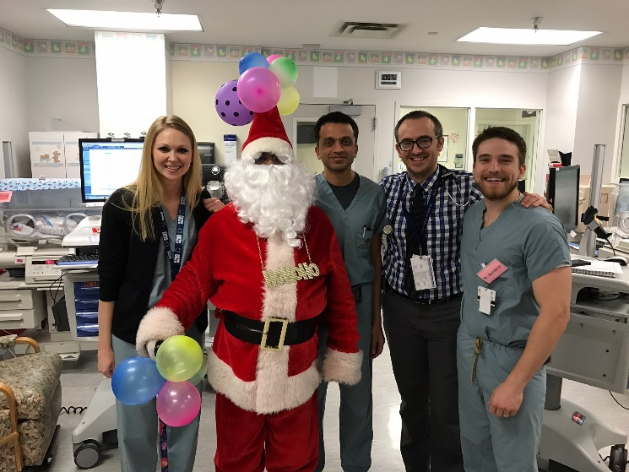

-Banks-
Listed below are various banks that residents use. Most important- set up direct deposit and make sure you have access to your bank account online- it makes life so much easier!

Amegy Bank: 2303 W. Holcombe Blvd, Houston, TX 77030

Bank of America: Great physician mortgage, ATM’s in TCH and all over the area. Mobile app allows you to take pictures of checks to make a deposit, thus saving you a trip to the bank. 1020 Holcombe Blvd, Houston, TX 77030, (713) 790-1000

BCM Federal Credit Union: Great loan rates, in the medical center: One Baylor Plaza, Houston, TX 77030 (713) 798-4820

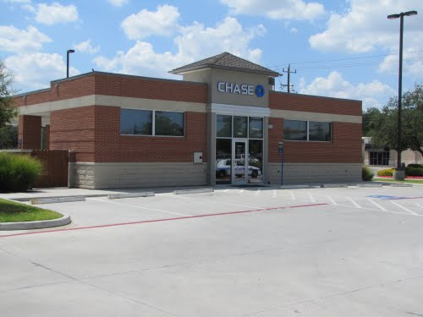
Chase: Convenient (there are 2 on Fannin- one across the street from TCH): 6560 Fannin, Houston, TX 77030, (713) 795-7312

Cap One: Has fee free credit cards that are great to use when traveling out of the country.

Compass Bank: No fees for ATM’s. 7390 Fannin, Houston, TX 77030 (713) 867-2128

Iberia Bank: Ask for Charley Katz, great guy and very helpful. 2555 West Holcombe, Houston, TX 77030 713-667-3077

Online/Internet Banking: Very convenient, reliable, inexpensive, examples include: ING Direct and Everbank

Wachovia: Multiple convenient locations: 2264 W. Holcombe Blvd

Wells Fargo: There is a Wells Fargo in the TCH Pavilion for Women building. Or you can go to the traditional branch across the street at from TCH at 6621 Fannin St. A1.2001.

-Child Care-

The good news is that if you are coming to Houston with your family or if you are planning to start your family during residency, you have a lot of support coming into our program! We have many kids, and trust us; your upper level parents have explored their options for child care extensively. Please make sure you ask around for advice-- people have gone through this before and have great recommendations!

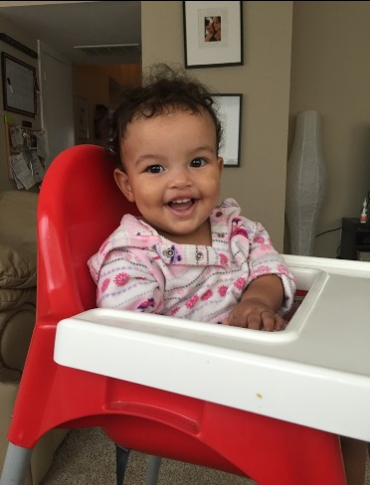
Here are some nice basic tips:

Day Care Options:

For families that have decided that preschool is the best option for their little one, here is a short list.

Robindell Private School near Bellaire- open 24/7 except for 3 days a year (Christmas, Easter and Thanksgiving), Bertha Alyce Center, Montessori Country Day School, Montessori Cathedral House, Beth Yeshurun Day School, United Orthodox Montessori, Becker Day School, St. Nicolas, Post Oak School, Creme De La Creme (more institutional, chain, but seems well run) are all good choices.

The city is full of great daycare options from Montessori programs to church-based daycare. Several of the programs that are in higher demand have a waiting list of up to 6 months, so it’s a great idea to put in an application as soon as possible. In addition to providing a safe, fun and educational environment for kids, one of the most significant factors in finding a good daycare is the operating hours. As the resident workday often begins early and may end late, extended hours can be life savers if the resident’s partner can’t always drop off/pick up. Make sure to inquire about the fee for being late—fees can be as much as several dollars a minute.

Thankfully Baylor offers as one of the resident benefits in-home back-up care for the mildly ill child (up to 80 hours per calendar year), which helps ease the issue of increased illness for kids attending day care.

More helpful tips…. The best advice for having a child during residency is to find your "team". It is a very difficult and demanding time and you bear a level of stress other residents can't understand when dealing with schedules and long hours. Every situation will be unique. You need your support system. Find your "team" of people who you can rely on and who are all on the same page regarding you and your child's needs/schedule (husband, family, nanny, babysitter, family friend etc).


Nanny Services:

For families who decide they would like in-home care, there are several reputable nanny agencies in Houston including Morningside Nannies (expensive 10% placement fee, search charge), Motherhood Center, River Oaks Domestic Agency (flat fee, no search charge), Domestic Help Agency (flat fee, no search charge). Another invaluable resource for finding a nanny is Bellaire Young Mothers (a local support group for moms with a yahoo group where individuals post information on available nannies, babysitters and more).

There are numerous nanny agencies, although there is a significant finding fee. On the extreme end of the nanny spectrum, it is possible to find an au pair. One of the best ways to find a nanny is to watch for e-mails from other residents or faculty looking for positions for nannies that are leaving the family. These are sent occasionally and are great way to find a tried- and- true employee.

Bellaire Young Mothers Listserve (Only for Bellaire Residents) It is a free service and an e-mail goes out daily with posts from moms/families whose nannies are looking for jobs. It is a members-only, free service and all nannies are highly vouched for by their previous employers. The daily email also includes posts from moms who are selling baby items and clothing on the listserve, so it is a great resource for all kinds of things. Highly recommend!

Many residents and attendings share nannies, so send out an e-mail to the resident listserve, and ask around. Everyone is more than happy to help and pass your name along to friends.

In Pearland:
Many churches have “Mother’s Day Out” programs which offer part-time child care/preschool from 2-5 days a week.



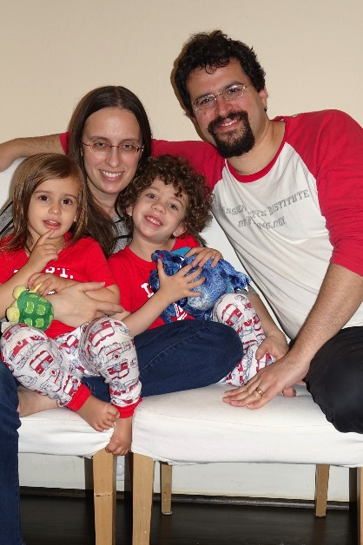

More Tips from Residents:
- Robindell Private School near Bellaire- open 24/7 except 3 days a year (holidays)

- “Join “Bellaire Young Mother’s Club” and post a request for a nanny you will get excellent options without paying a finder’s fee.”

- “UT Houston has a good day care that is open early in the morning and late at night.”

- Little Miracles: 2501 Dorrington St., Houston, TX 77030 (713) 668-7300

- “I have heard that www.nannies4hire.com is a good source- recommended by Dr. Phil.”

- BYDS Yeshurun Day School (has been an excellent childcare option near the medical center and somewhat more affordable than some of the other options. Jews and non-Jews alike are all welcome)

- TMC YMCA Daycare - <5 min drive from work, price (approximately $550/mo), diversity (very diverse group of children), teachers longevity (some 20+ years), and operating hours (open from 6am-6:30pm M-F, and you can drop-off/pick-up any time within those hours (there's no 10-hr limit/day like a lot of daycare centers).

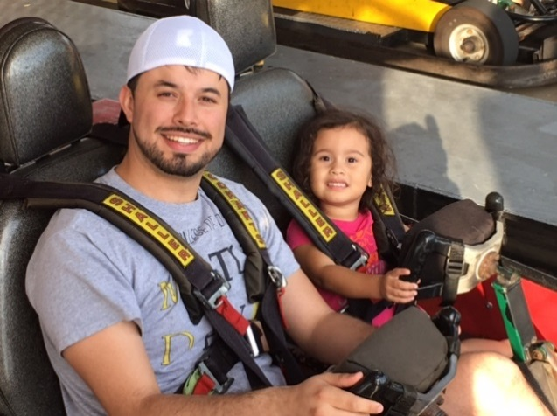

~Dental Care~
Residents give their input on the best dentists in town:
Cambridge Dental: 8526 Cambridge St. (713)-790-1111; close to med center!
Dr. Jeremy Chance: 2511 W. Holcombe Blvd. (713) 666-0003. “He is a GREAT dentist! Highly recommend and he is so close to the med. center!”
Dr. Lily Chen with Bellaire Family Dentist: “I love her; she is the BEST” 4747 Bellaire Blvd., Ste 30, Bellaire, TX 77401, (713) 665-2088
Dr. Estandiari at Holcombe Dental Associates: 2329 W. Holcombe, Houston, TX 77030, (713) 667- 9311
Dr. Deborah Hasse: 2522 Nottingham St, Houston, TX 77005, (713) 521-1202
Dr. Helen Jafari: 8535 W Bellfort St, Houston TX 77071
Lukin Family Dentistry in Sugar Land (father/son team): 4655 Sweetwater Blvd., Ste. 400, Sugar Land, TX 77479, (281) 265-9000
Dr. Theresa McLean: 1123 Lehall St., Houston, TX 77030-4911, (713) 790-1314
Memorial Heights Dentist: 920 Studemont St, Houston, TX 77007, (713)869-0600
Dr. Peoples at Diamond Dentistry: 5323 Weslayan St, Houston, TX 77005,
(713) 664-8000
Dr. Deborah Phan: 7505 Fannin Ste. #214, Houston, TX 77054, (713) 797-6453
Dr. Saliba: 4101 Greenbriar Ste. 220, Houston, TX 77098, (713) 528-3362
Dr. Anju Syal: 7707 Fannin (150), Houston, TX 77054, (713) 790-1111
Dr. Steven Vaughan at Contemporary Dental: “We went to school together; they are really nice and take our insurance.” 4562 Bissonnet, Bellaire, TX 7740, (713) 668-9119
Dr. Minh-Thu Tran: 2518 Tangley St Houston TX 77005, (713) 874-1500
BLVD Dentistry 2402 Rice Blvd, Houston, TX (281)833-0101 They offer free whitening at first visit!

Pediatric Dentists:
Dr. Rita Cammarata at: http://www.kids-teeth.com
Dr. Sadhya Harpavat at: http://www.dds4childrenpearland.com

~Physicians~
Family Practice:
Baylor Express Care Clinic: Specifically designed for faculty, residents and med students for same day appointments, acts as an urgent care, and is on campus. Not to be used in place of a PCP, but definitely helps when you’re in a bind and need to be seen! 6620 Main St., 12th Floor, Suite 1250. Call 713-798-WELL (9355).
Baylor Family Medicine: “Dr. Leugers is great, as well as others in the practice are recommended; convenient, same day appointments, many things online, very personable!” 2701 Kirby, Ste. 100, Houston, TX 77089 or Baylor Clinic: 6620 Main St. Ste. 1250, Houston, TX 77030, http://www.baylorfamilymedicine.org
Houston Family Practice: Dr. Elizabeth Knafo, Dr. Georgine DeRoth, and PA Joe Graham “You can see the PA the same day, also do well women exams!”
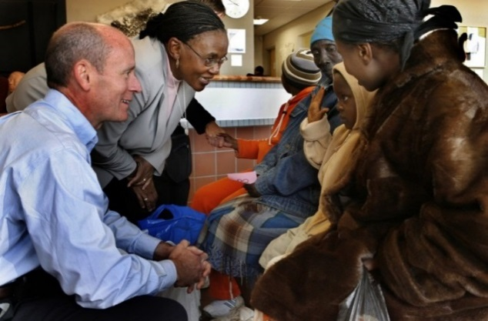
Internal Medicine:
Dr. Andria Cardinalli-Stein: Former Baylor internal medicine chief resident. Medical Plaza 3, 915 Gessner, Ste. 100, Houston, TX 77024, (713) 242-2222
Kelsey-Seybold: Http://www.kelsey-seybold.com/
Dr. Scott Lisse: 6560 Fannin St., Houston, TX 77030
Medical Clinics of Houston: Dr. Dawn Stoecker-Simon, Dr. Jennifer Meyer, Dr. Cynthia Williams, and others are recommended. “Dr. Williams is WONDERFUL” 1707 Sunset Blvd., Houston, TX 77005, (713) 526-5511 http://www.mchllp.com

OB/GYN:
Baylor Clinic OB-GYN: Drs. Timmons, Raine, and Leong-Kee
6620 Main St. (713) 798-7500, http://www.baylorclinic.com/services/obstetrics
Complete Women’s Care Center: Has an all women staff 7900 Fannin St., Ste 3000, Houston, TX 77054 713-791-9100
Dr. Wanda Mott of the Women’s Specialists of Houston: St. Luke’s Medical Tower/ Medical Center, 6624 Fannin, Ste. 1800 (713) 797-1144 www.womenspecialists.com
Dr. Joseph Salinas of the Women’s Center- Kelsey Seybold:
7900 Fannin #2100, (713) 442-7300. “He is such a great physician!”
Dr. Susan Shi: 6651 Main St., Suite F760, Houston, TX 77030 713-335-0335

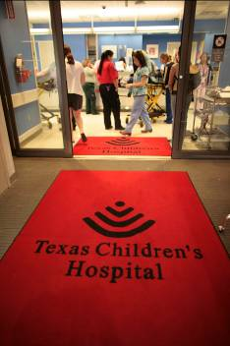
Ophthalmology:
Baylor Ophthalmology: Discounted rate for PRK and Lasik for residents/ physicians, (713) 798-6100
Berkeley Eye Center: 3100 Weslayan, 4th Floor (713) 526-1600, www.berkeleyeye.com Eye Care Central in Midtown: 1202 Elgin Street. Dr. Vo is so nice and professional and his office always gets me in last minute when I forgot to order my contacts right before the end of the year and need to spend my last Flex money.

Pediatrics:
Greenbriar Pediatric Medical Group (TCPA): 4101 Greenbriar, Ste 100, (713) 526-6443 http://www.texaschildrenspediatrics.org/
Dr. Maggie Jimenez (Former BCM Attending)
1901 Kirby Dr. Ste. 109, Pearland, TX 77584
713-512-8600
Kristin Koush (TCPA): 2007-2008 Baylor Pedi Chief “She is wonderful”
Houston Pediatric Associates (TCPA): Drs. Lisa Rowland and Brooke Lasics,
4110 Bellaire Blvd. Ste 210. (713) 666-1953
Dr. Janet Pate (TCPA Practice): Former Baylor Pedi Chief- she is wonderful! 3838 Hillcroft, Ste 215, Houston, TX 77057
Pearland Pediatrics: “I’m biased as I worked there for two years and I would especially recommend Drs. Decker and Gray.” 2017 E. Broadway, Ste A, Pearland, TX 77581, (281) 485-9990, http://pearlandpediatrics.com

~Pets~
Veterinarians (many of these see exotic pets, too!):
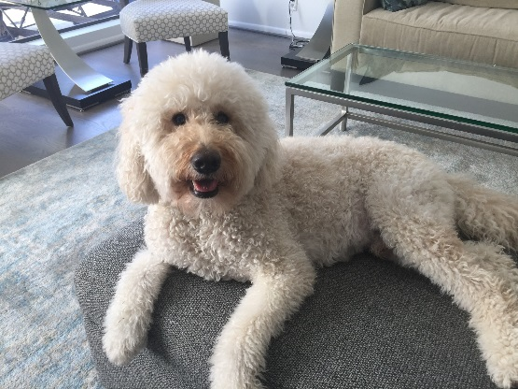
Petsmart: They have a very good “health plan” that covers all vaccines; all vet visits, neutering, dental cleanings under anesthesia, boarding and grooming, etc. They have great hours including dropping off in the AM and picking them up late. 8230 Kirby Dr., Houston, TX 77054, (713) 662-2553
Midtown Veterinary Hospital: Dr. Ferrer is great. You can drop off in AM and pick up later for an apt, also open Saturdays. 1434 W. Alabama St. (713) 528-4900
Meyerland Animal Clinic: Dr. Vining is an EXCELLENT vet and is very knowledgeable (also has boarding and late hours). 4995 W. Bellfort Houston, TX 77035
(713) 723-8612 http://www.meyerlandanimalclinic.com : Also a good place for boarding and doggie daycare.
1701 Montrose Blvd. 77006 (713) 524-3814 http://www.montrosevetclinic.com/
Pearland Animal Hospital West: Have boarding, daycare, and grooming as well. 1601 N. Main St. (Hwy 35) in Pearland, TX 77584(281) 485-2496 &
10015 Broadway, Ste 6 (518) in Pearland, TX (713) 436-9400
http://www.pearlandanimalhospital.com/
Petcare Express: Excellent for small procedures, shots- VERY inexpensive and they have an excellent reputation. 2501 W. Holcombe Blvd. 77030 (713) 592-9977 www.petcareexpress.net
Rice Village Animal Hospital: Good hours, great vets, boarding and grooming as well. 2348 Rice Blvd @ Greenbriar, (713) 527-0489
Southside Place Veterinary: Super nice and uses evidence based medicine. “We drive out of our way to go here. Good for boarding as well.” 6902 Stella Link, Houston, TX 77025 (713) 349-0718 http://www.southsideplaceanimalhospital.com
Westheimer Animal Clinic: Dr. Huddleston (boarding, doggie daycare, and doggie spa as well) 7005 Mapleridge, Bellaire, TX 77401 (713) 622-1270
http://www.wacbellaire.com/
Boarding & Doggie Day Care (see above as well):
Midtown Dog Kennel: Run by a retired RN and cop. It is in a (not so great) area near downtown, but the rates are great. They have an adjacent yard the dogs can run around in. They know our dogs by name. If there aren’t many dogs, they get extra play time outside. 1416 Nagle St. Houston, TX, (713) 227-1167
Rover Oaks: (dog sitting, grooming and doggie daycare); Everyone is really nice, they get to know your dogs/cats very well and take excellent care of them, can be on the expensive side. 2550 W. Bellfort (713) 662-2119, http://roveroaks.com
Urban Tails: (boarding, dog sitting/ grooming): They know your animals by name and take excellent care of them! They also have a dogcam so you can watch your pets online while you are away! 1618 Webster (Midtown), (713) 558-0900, http://www.urbantails.cc/
Pet Palace: It’s in Clear Lake and a bit of a drive, but they have the best rooms and care for our pets. 14300 Gulfstream Park Dr., Webster, TX 77598 (281) 484-PETS www.thepetpalace.net
Dog Parks:
Check out this website for a list (and maps!) of all the dog parks in Houston! Great descriptions of what to expect when you are there and the rules of the dog parks: http://www.houstondogpark.org

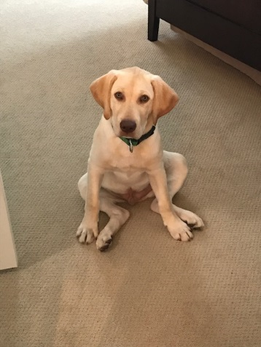
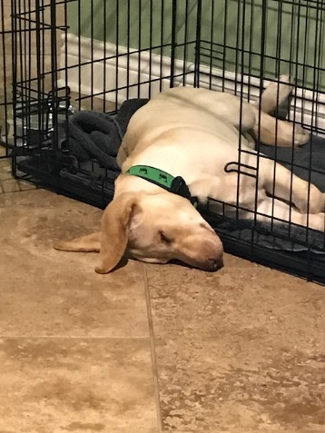
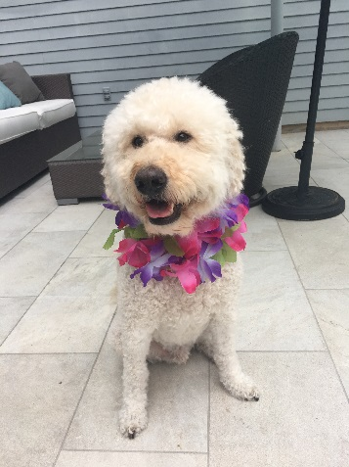
~Churches and Places of Worship~
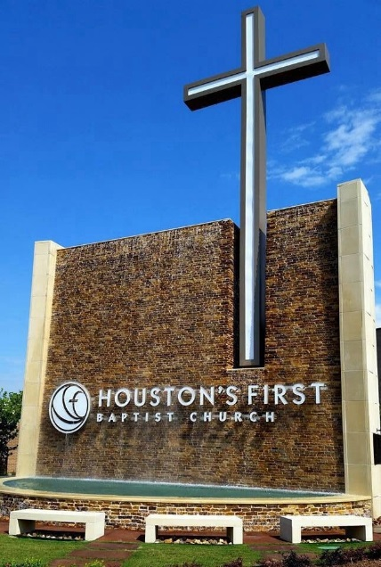
Baptist:
First Baptist (a fairly traditional Bible church with very structured small groups): 7401 Katy Freeway (713) 681-8000 www.houstonsfirst.org
Second Baptist: 6300 Woodway, Houston, TX 77057 (713) 465-3408 http://www.second.org
Wheeler Avenue Baptist Church: 3826 Wheeler St, Houston, TX 77004 · (713) 748-5240, www.wheeleravebc.org
West University Baptist Church: (Has traditional and contemporary services. They also have a young professionals bible study taught by a nephrologist) 6218 Auden St, Houston, TX 77005, (713) 668-2319 http://www.wubc.org

Bible Churches:
Grace Bible Church (in the heights): 6325 Hurst Street (832) 242-7957 Great mix of single people and families. Several residents attend here. Officially part of EFC but has nondenominational feel. Strong small group component. Night service allows flexibility when on late stays and call months! www.gbchouston.com

Catholic:
The Rice University & TMC Catholic Student Center: (Sunday evening services with dinner afterwards, very casual) 1714 Rice Blvd. (713) 526-3809
http://www.ruf.rice.edu/~cathcen/
St. Anne’s Catholic Church: 2140 Westheimer (713) 526-3276 www.saintanne.org
St. Teresa’s in Memorial Park (Catholic Church): 6622 Haskell Street
(713) 869-3783 www.sttheresa.cc
St. Vincent de Paul Catholic Church: “It’s nice; I like the priests there.”
6800 Buffalo Speedway (713) 667-9111, www.stvincentcatholicchurch.org
St. Michael Catholic Church: 1801 Sage Road. 713-621-4370, www.stmichaelchurch.net

Methodist:
Westbury United Methodist Church: “I love my church!” 5200 Willowbend
(713) 723-0175, www.westbusyumc.org
Non-Denominational:
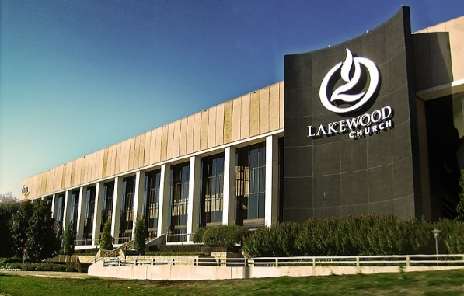
Houston Chinese Church (non-denominational): 10305 S. Main St. (713) 662-7550 http://www.houstonchinesechurch.org
Lakewood Church (non-denominational): 3700 Southwest Fwy (713)635-4154 www.lakewoodchurch.com It’s not as large as it looks. Pastor Joel is very approachable and available to meet all who attends. English and Spanish services

Not Specified:
Crosspoint Church: (Has contemporary services with great worship. Also has a good young couple’s bible study.)
4601 Bellaire Blvd at Avenue B in Bellaire, TX (832) 203-4300 www.cpointchurch.org
Ecclesia (a pretty modern place with amazing community): 1100 Elder St, Houston, TX 77007 (713) 662-1846 www.ecclesiahouston.org
New Hope Church: (Pearland/Manvel area) It’s off 288 on CR 58.
3640 County Road 58, Manvel, TX 77578, (281) 604-4000 www.newhopechurch.org
Palmer Memorial: “It’s quite friendly, but can be crowded as it is small.” 6221 Main Street (713) 529-6196, www.palmerchurch.org
WatersEdge Community Church: 3743 Garnet ST., Houston, TX 77005 watersedgehouston.org

Presbyterian:
Christ the King Presbyterian: (PCA) 5601 W. Loop South, Houston (713) 892-5465 www.christtheking.com
City of Refuge Evangelical Presbyterian Church: Near the medical center, diverse population, young crowd. “It’s awesome, great music, good community, lots of residents.” 3150 Yellowstone Blvd. (713) 664-5033 http://cityofrefuge.org
First Presbyterian: 5300 Main Street (713) 620-6500 www.fpchouston.org
“Great church, very close to the medical center, and the Pastor is awesome!”

Jewish Synagogues
Beth Yeshurun (Conservative): 4525 Beechnut St (713) 666-1884, www.bethyeshurun.org
Beth Israel (Reform): 5600 N Braeswood Blvd Ste B (713) 777-4315, www.beth-israel.org
Emanu El (Reform): 1500 Sunset Blvd (713) 535-6400, www.emanuelhouston.org
Reform Synagogue of Houston: 801 Bering Dr (832) 426-4392, www.hcrj.org

Hindu Temples
Swami Narayan: 1150 Brand Lane, Stafford, Texas 77477
Meenakshi Temple: 17130 McLean Rd, Pearland, TX 77584

Mosques
There are many beautiful mosques in Houston. This is the best website to find them: http://www.isgh.org
There is also an iphone app to help you find them, called ISGH Masid.


~Exercising and Gyms~
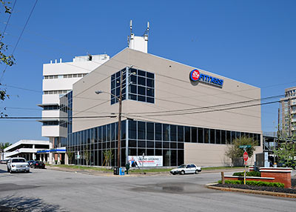
Gyms:
For a list of Gyms/ Fitness programs that offer BCM Discounts visit: BCM Intranet > Human Resources > Benefits > Fitness Program Discounts

24-Hour Fitness: Rice Village location is brand new! Tell them you are a BCM employee and you will get a discount! There are many locations in Houston with lots of classes http://www.24hourfitness.com/
Bally Total Fitness in Rice Village: Convenient 2500 Dunstan (713) 521-3113
Class Pass: allows you to visit >50 gyms in the Houston area and has a convenient app to sign up for classes (Crossfit, Pilates, Yoga, Spin, etc.) Membership is $89/month but often has deal for first time buyers. Allows ultimate flexibility to attend fitness classes on a busy schedule, and is a great way to try out a variety of gyms/studios and determine which one is your favorite.
Discovery Green Park: offers FREE classes: Zumba, Pilates, and Yoga. Check out www.discoverygreen.com > Event Calendar for times.

Fit Athletic Club: Texas Children's employees have a small discount. Really nice with great classes and facilities- a bit more expensive 1532 W. Grey Street (713) STAYFIT
Houston YMCA: Weekly Family YMCA used by many residents 7101 Stella Link Blvd. (813) 664-9622, multiple locations as well. No sign-up fee with TCH ID.
LA Fitness: location in Holcombe Blvd is convenient to the medical center, has free parking, and offers a discount to Baylor employees with monthly membership $39/month.
UT Health Center Gym: There is a med center discount for residents. Features include: outdoor heated pool, good cardiovascular units, great weight area, basketball & racquetball courts, and exercise classes. Very close to med. center! 7779 K night Road (713) 500-8420
Tennis:
The Houston Parks & Recreation Department provides 3 tennis centers with 60 lighted, outdoor, hard courts for citizens’ enjoyment (The Memorial Park Tennis Center, the Lee LeClear Tennis Center, and the Homer Ford Tennis Center). You have to pay to use these (minimal fee). In addition to the staffed tennis centers, the department provides 145 tennis courts in 78 neighborhoods across the city! All free of charge! Check out this website for a complete list of public tennis courts: http://www.houstontx.gov/parks/tennis.html
Houston Tennis Association: http://www.houstontennis.org/index.asp
Courts used more frequently by residents: Rice, West University, Hazard St. (Rice)
Disc Golf:
For a list of disc golf courses in Houston visit: http://www.houstontx.gov/parks/discgolf.html (MacGregor Park off Old Spanish Trail is the closest course to the medical center)

Rock Climbing:
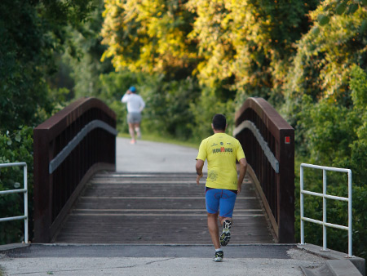
Momentum Silver Street, Texas Rock Gym, Inspire, Stone Moves

Jogging:
- Allen Parkway
- Rice University “Outer Loop” 3 mi, “Inner Loop” 1.4 mi. Alex Siller (PGY-2) has a running club, so keep an eye out for emails!
- Memorial Park (running trail, mountain bike trail, tennis courts, soccer field, driving range)
- Hermann Park
- Many Neighborhoods: West U, Shadow Creek Ranch
  - Buffalo Bayou (pathways for pedestrian only and pedestrian + bicyclist). Also has a dog park and several new renovation projects: http://buffalobayou.org

Parks:
List of parks and other city recreational centers: http://www.houstontx.gov/parks
Map of parks in central Houston: http://www.buffalobayou.org/citymaps.html
Parks for camping/ nature walks: http://www.wildtexas.com/parks/results.php?nearby_cities=Houston
State Parks: http://www.tpwd.state.tx.us/spdest/findadest/gulf_coast/

~Tailors and Dry Cleaning~

5th Avenue Cleaners: 2302 Bissonnet Street
American Cleaners: (cheap!)5314 Almeda
Bridals by Nancy Tailoring and Alterations: Super nice, reasonable prices and does a great job on all kinds of clothes – men and women. 713-529-5710
Carol’s Alterations & Cleaners: 1562 W. Gray
Collegiate Cleaners in village: a little more expensive, but dependable! 2430 Rice Blvd
Chinh Tailor: 3118 Hamilton Street. Fast, professional, and affordable. 1 day turnaround.
Fannin Cleaners: 7135 Fannin St
Houston Shoe Hospital: 5215 Kirby (tailor & shoe repair)
Lebon Cleaners: 5821 Kirby Dr
Marcello’s Alterations: 5015 Westheimer (in Galleria), same day for tailoring/ regular dry cleaners. Usually do hems, etc.
Martin Tailors: 4712 Feagan St. 713-861-4891
Nick Lopez Tailoring: 2680 Sage Rd. 713-621-5411
Pearland Dry Cleaning: 3402 FM 518 # A (In Silverlake)
Regency Cleaners/ Tailor: (Rice Village, good & reliable) 2503 Rice Blvd, 713- 524-6941
Rice Dry Cleaning: 2366 Rice Blvd (near Rice Epicurean)
River Oaks Cleaners: 3907 Bellaire Blvd.
Tony’s Alterations: 2415 Bissonnet St, 713-523-3727, quick, good prices, and quality work. Trend Tailors: 2533 Times Blvd
US Tailor: 2514 W. Holcombe Blvd (wonderful seamstress who does quality work!)
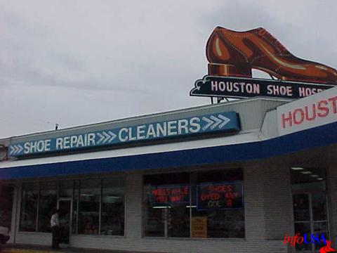

~Haircuts and Salons~
Beautique in Rice Village: 2507 Times Rd. (713) 526-1126 www.beautique.cc
Billie Jean’s Hairstyling & Wig Salon: great and cheap haircuts for men, 2403 Shepherd, (713) 523- 7895
Clique Salon in Rice Village: 2414 University, Ste. 220 (713) 807- 8300 www.cliquesalon.com
Cosa Bella Salon in the Heights: 1543 Yale Street (713) 869- 1441, www.cosabella-salondayspa.com
Doug’s Barber Shop in the Heights: Great for an old-school “guy” haircut. 219 E. 11th St. (713) 862-0670
Hair Fashion Salon: Very cheap, ask for Mayra! 8057 Kirby Dr. 713-799-9040
Hair by Rigos: ($10 on Tuesdays for men’s cut) 3887 SW Freeway (713) 653-9195, http://hairbyrigos.com/index.html
Hare Repair: 5815 Star Lane, Trustworthy, competitive pricing, good people. 5-star Yelp rating for a season.
Roosters: Men’s grooming center; they serve beer! 4001 Bellaire Blvd., (713) 661-6700
Salon-trose: Ask for Yvonne Roman. 3820 Roseland St. 713-640-5554
Supercuts: Multiple locations: www.supercuts.com
Tony & Guy at Galleria: 5015 Westheimer Rd. Ste 2290 (713) 871- 9340
Touch of Red Salon: 2402 Montrose Blvd (713) 524-1400 www.touch-of-red.com
Upper Hand: 11805 Westheimer, #390, (281) 497-8280, www.theupperhand.com
Young’s Barber Shop: 3811 Kirby, (713) 528-9524
Angel’s Nails: 2203 Richmond Ave
Isle Pedi Spa: 5819 Kirby Dr
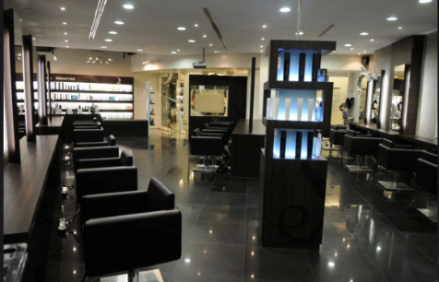
Nails Unique: 3733 Westheimer Rd
Natural Resources Hair Salon: 5313 Morningside Dr
Paradise Nails: 2617 W Holcombe Blvd # E
Rice Village Nail and Spa: 2368 Rice Blvd
Roula’s Nail Salon: 3017 Kirby Dr
Sweet Escape Nail Lounge: 2272 W Holcombe Blvd
Tulip Nail Salon: 2521 Rice Blvd
~Auto Repair Shops~

Arthur’s Auto Service: 10840 Craighead, can ride the #10 Metro bus to Med. Center Transit Center. Very honest and reasonable, can make appointments.
Brake Check: 3825 South Loop W, 713-666-2472, www.brakecheck.com (Make your appointment online for a 20% discount)
Discount Tires: Reasonable prices. Will even drop you off at work and pick you up. 9402 Stella Link, 713-432-0014
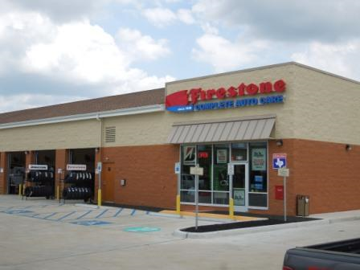
Car Spa: 2801 Brazos Street. For your oil changes, state inspections and minor repairs (713) 523-5583, www.carspa.net
Cornerstone Automotive: 9734 Broadway St. in Pearland. Good Prices
Cunningham’s Auto Repair: 8600 Knight Rd
Eric’s EXXON: 6950 Kirby Drive (They also do oil changes and inspections; we trust them.)
Firestone: 5300 Westheimer
The Honda Car Shop (Honda or Toyota): 3602 Dunvale. “They are really great if you have a Honda or Toyota. They won’t rip you off and are open on Saturday; you can go to House of Pies while you wait!”
Joe’s Auto Repair: 7040 Stella Link Rd, good mechanical work, reasonably priced.
Midtown Auto Repair: 4510 Almeda Rd
MD Automotive: 6975 Almeda Rd. Will drop you off at med center if needed!
NTB: Multiple locations, http://www.ntb.com/tires/Store-Locator.j.
Poutous Auto Repair: 4601 Kelvin Drive. “Not dirt cheap, but honest and do quality work.”
Progressive Auto Repair: 5131 Glenmont Drive.
RMS Auto Care: 1759 Westheimer Rd, Houston, TX 77098 (713) 529-5855

~A/C Repair and Plumbers~
A1 Tops Service: 8950 Westpark Drive, #305. “They are not that expensive and they clean and maintain your AC system.” 713-783-2665
Air Temperature Incorporated: 2507 South Blvd. “Possibly pricey, but their repairs have lasted me.”
ARS for Plumbing: “They have services available 24 hours, though you pay extra after 8pm. They also do AC’s, etc.” 713-777-7777
Cool & Heat AIRCO, Inc.: 7113 Atwell. 713-272-6262. “Very friendly and win BBB awards.”
Pro Built (Owner Jimmy L. Walker): 11915 Atwell Drive. 713-723-7766, www.probuilt-hir.com “He did a really good job installing my ceiling fans and light fixtures.”
Village Plumbers: 5403 Kirby Dr. 713-224-DRIP

~Recycle~

We really like recycling! Here is the website on Houston recycling opportunities: http://www.houstontx.gov/solidwaste/recycling.html
Westpark Consumer Recycling Center: 5900 Westpark (also includes tires, BOPA, and Scrap Electronics recycling)
Environmental Service Center (South): 11500 South Post Oak (For household hazardous waste and scrap electronics recycling only)
Kirkpatrick Depository: 5565 Kirkpatrick (Tires and oil also)

Central Street Depository: 2240 Central Street (Tires and oil also)
Sunbeam Depository: 5100 Sunbeam (Tires and oil also)
3602 Center: (newspaper, magazines, office paper; glass food & beverage bottles and jars; #1 & #2 plastic jugs; tin & aluminum food cans; cardboard boxes-broken down) –Open 24/7

~Learning Spanish~


“I actually took a 2-month course at Rice University School of Continuing Education for 2 months, twice a week in the evenings. Cost: $460. This was a really good, fast paced course, but obviously can be tricky on call rotations. I have used every bit of what I learned.”

There are many other classes at local churches and communities –mostly in the evenings.

The AAP has also published a wonderful pocket-book: Spanish for Pediatric Medicine, which is just the right size to fit in the coat pocket, yet comprehensive enough to cover topics ranging for well child visits at different ages to the consistency, color and odor of different bodily emission in the sick child. About $25- there is also a PDA version.
There’s a good book entitled Breaking out of Beginner Spanish, which helps with conversational Spanish (if you’ve had some classroom Spanish, but are trying to make the next leap), but it doesn’t have any medical content.

Medical Spanish by Gail L. Bongiovanni, published by McGraw-Hill ,An Introduction to Spanish for Health Care Workers- Communication & Culture by Robert O. Chase & Clarisa B. Medine de Chase.

http://www.spanishovercoffee.com: “My friend used this group; he really liked it and it helped with his Spanish.”

~Shopping~

Food:
Central Market: Wonderful produce, BEST food, expensive. 3815 Westheimer www.centralmarket.com
Chinatown: (59 and Bellaire) Tons of cheap groceries, good produce (also lots of great restaurants!). Hong Kong Food Market has a nice selection. www.chintatownconnection.com
Farmer’s Markets: Fresh Produce! Canino’s (is the best) on 2520 Airline- open every day, Tuesday nights at Rice, Saturday mornings at 3000 Richmond. Here is a complete listing of Farmer’s Markets in Houston: www.visithoustontexas.com/visitors/farmers_markets
Fiesta: International foods, cheap, multiple locations www.fiestamart.com
HEB: A Texas born chain and a staple if you’re going to call yourself a Texan! Great produce, bakery, and fresh meats at reasonable price. Multiple locations www.heb.com.
Kroger: Convenient, multiple locations, www.kroger.com
Trader Joes: They buy direct from suppliers and bargain hard to get the best price, and then pass the savings of organic foods, straight to you. www.traderjoes.com
Whole Foods: Nice produce, all organic, nice prepared meals, more expensive. Convenient- locations on Stella Link & Bellaire, Kirby & W. Alabama www.wholefoodsmarket.com
Everything (even the things you didn’t know you needed…)
Costco Warehouse: Membership based warehouse/wholesale. Good prices, buy things in bulk. New location being built at Richmond & Weslayan www.costco.com
Super Target: Very convenient, good prices, and Main Street location is close to the medical center. www.target.com
Sam’s Club: Fannin & 610. Membership based warehouse/ wholesale, can have good gas prices. www.samsclub.com
Wal-Mart: Nice & cheap! Multiple locations, including Meyerland & Pearland.

Shopping Areas:
Boutiques in the Heights: fun to walk around, multiple independently owned shops that sell clothing and gifts on 19th Street.
First Colony Mall in Sugar Land: www.firstcolonymall.com
Galleria: has everything, but is always crowded. www.galleriahouston.com
Highland Village: Banana Republic, J. Crew, Pottery Barn, Ann Taylor, Crate & Barrel, William’s Sonoma, Anthropologie and lot more! www.shophighlandvillage.com
Katy Mills: (Clothes & gifts- 45 min. or so away, but cheap!). Tons of outlet stores including Neman’s and Saks. www.katymills.com
Meyerland Plaza: More affordable, lots of options. Ross Dress for Less, Marshall’s, Borders and many more www.meyerlandplaza.com
Premium Outlet Center: 29300 Hempstead Rd, a great place to shop with 120 stores! http://www.premiumoutlets.com/index.asp
Tanger Outlet Mall: 5885 Gulf Fwy, towards Galveston on i-45 S
Rice Village: nice variety in a small area, convenient, but can get busy on Saturdays and during lunch time, many nice restaurants and shops. www.ricevillageonline.com
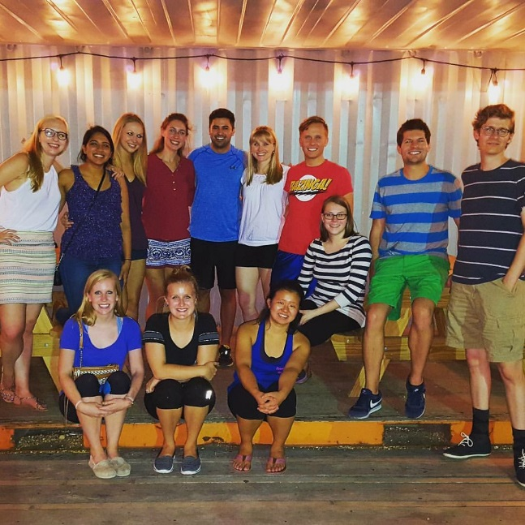
River Oaks Shopping Center: Sur La Table, Ann Taylor, Saint Cloud, GAP, etc
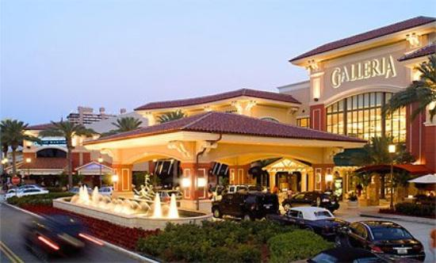
~Special Recommendations~
Berings: Nice place for gifts. Multiple Locations- www.berings.com
Buffalo Exchange (thrift store): Multiple locations www.buffaloexchange.com
Ikea: Cheap, but decent quality! 7810 Katy Freeway at Antoine www.ikea.com
REI: Nice store for the outdoors! 7538 Westheimer Road www.rei.com
Running Shoes: Fleet Feet in Rice Village, Luke’s Locker in River Oaks or On the Run, also good places to find out about running events, clubs, etc.
Suit Mart (for guys): Deep discounts! Multiple locations www.suitmart.com

~Our Favorite Things to Enjoy
in or Around Houston~
Hill Country: Includes many nice vineyards, Fredricksburg, Austin, Wimberly (small city outside of Austin), New Braunfels, San Marcos
Austin: 3 hour trip on 290 west or take I-10 to Hwy 71. Austin city limits music festival in September, three lakes, hiking and bike trails, Texas State Capital, 6th street (long stretch of bars, res0taurants, entertainment)

Dallas/Fort Worth: 4 hour trip on 45 north. Aquarium, Dallas and Ft. Worth Zoo, Six Flags Over Texas, Hurricane Harbor, Texas Rangers and Dallas Cowboys Stadium, Ft. Worth Stockyards, and shopping
Galveston: 45-60 minutes on 45 south. Visit the beach, the Strand, the Boardwalk, Pleasure Pier, Moody Gardens, and various shops!
Kemah Boardwalk: 20 miles south on 45. Amusement park, boat arena, lots of restaurants
San Antonio: 196 miles West on I10. Alamo, river walk- lots of great food and shopping!
Woodlands: 45 minutes on 45 north. Concerts at Cynthia Woods Mitchell Pavilion, Woodlands mall, Woodlands Resort, dining, etc.


Professional Sports:
Astros: (baseball) www.astros.mlb.com
Dynamo: (soccer) www.houston.mlsnet.com
Rockets: (basketball) www.nba.com/rockets
Texans: (football) www.houstontexans.com

College Sports:
Rice University: www.riceowls.cstv.com
University of Houston: www.uhcougars.cstv.com

Museums:
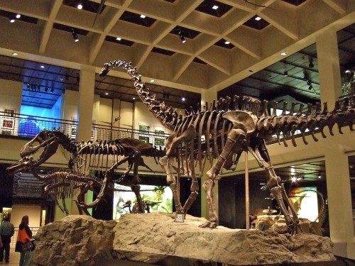
Children’s Museum of Houston: 1500 Binz, (713) 522-1138 www.cmhouston.org, free on Thursday evenings, 5-8pm
Contemporary Arts Museum: 5216 Montrose Blvd, (713) 284-8250 www.camh.org, everyday is free!
Holocaust Museum: 5401 Caroline Street, (713) 942-8000, www.hmh.org, Always free
Museum of Fine Arts: 1001 Bissonnet Street, (713) 639-7300, www.mfah.org, Thursdays are free!
Museum of Natural Sciences: One Herman Circle Drive, (713) 639-4629m www.hmns.org, free on Tuesdays from 2-8pm

Shows/Theatres:
Alley Theatre: www.alleytheatre.org
Broadway Across America: www.broadwayacrossamerica.com/Houston
Houston Ballet: www.houstonballet.org
Houston Grand Opera: www.houstongrandopera.com
Houston Symphony: www.houstonsymphony.com
Miller Outdoor Theatre in Hermann Park: free shows! www.milleroutdoortheatre.com Check out the free summer symphony nights and Shakespeare Festival! All lawn tickets are free. Covered seats are free and given out at the box office the day of the show. First come first served!
Angelika Movie Theater, Edwards Cinema, AMC, River Oaks, and Greenway Plaza

Miscellaneous:
Play golf: Wildcat Golf Course is the best driving course/range near the med. center www.wildcatgolfclub.com: Top Golf 1030 Memorial Brook Blvd, Houston, TX 77084 http://topgolf.com/us/houston-west
Houston Livestock Show & Rodeo: Houston Livestock Show and Rodeo Annual Cookoff (last weekend in February), Rodeo is every year in March (lots of concerts, food and rodeo fun! www.hlsr.com)
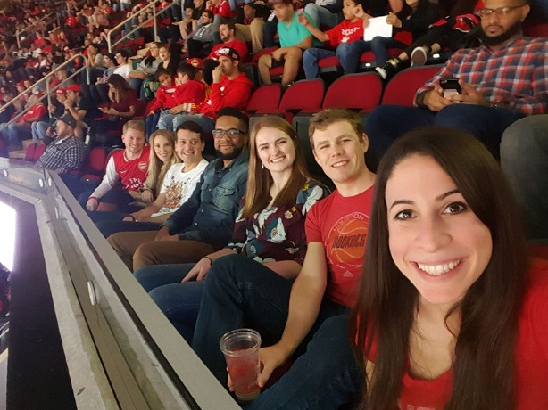
Houston Zoo: www.houstonzoo.org, 1513 MacGregor Dr, (713) 533-6500, Free on Holidays. Park in Garage 4 next to Ben Taub!
Visit NASA at Johnson Space Center (45 minute drive): www.spacecenter.org – memberships are really affordable!
Happy Hour Spots: The Village, Midtown, the Heights, Washington Ave, Uptown Park, City Centre, etc.

~House Staff Events Book~
The House Staff Office has tickets to various performing arts and sports events in addition to tickets for the annual Houston Rodeo (yeee-haw!). These tickets are raffled between the residents who sign up for each event. Come by to see if you can be the lucky winner!
~Houston Radio Stations~

HOUSTON RADIO STATIONS:
News:
88.7 KUHF NPR

Country:
- 92.9 The New 93Q
- 100.3 The Bull
- 97.1 Country Legends
Pop/Hip-Hop/Mix:
- 104.1 KRBE
- 96.5 The Mix
- 99.1 Sunny
- 97.9 The Box
Rock/Alternative/Oldies:
- 94.5 The Buzz
- 106.9 or 107.5 The Eagle Classic Rock
- 93.7 The Arrow Classic Rock
Spanish:
- 101.1 Mega 101
- 102.9 KLTN

Gospel/Contemporary:
- 92.1 Praise
- 89.3 KSBJ
AM Radio Stations:
- 740 KTRH News radio
- 950 KPRC Talk Radio
- 610 Sports Radio
- 790 Sports Talk
- 1070 News Talk
~Our Favorite Restaurants~
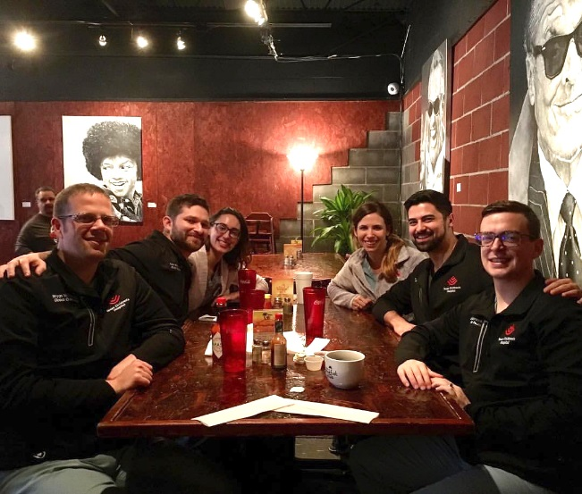
When we asked about favorite restaurants, we had no idea how much pediatric residents sure like to eat! Bon Appetit!

Price Guide (per person): $......... Under $20
$$....... $21-$30
$$$..... $31-$40
$$$$... Above $40
American/ General:
59 Diner: 3801 Farnham, good shakes and real diner food- also good for breakfast! Open ‘til midnight on Fridays and Saturdays! $
Barnaby’s Café: 604 Fairview, 414 W. Gray, 1701 S. Shepherd Dr. www.barnabyscafe.com $
Black Walnut Café: Rice Village- 5510 Morningside Drive- free wi-fi, good salads! Great place to meet after work. Great gelato, too! $
Empire Café: 1732 Westheimer Rd. Italian focus…GREAT cake and half price cake night on Mondays! Hoppin’ on the weekend mornings –nice brunch- and great place for people watching! http://www.empirecafe.com/ $
Hearsay Gastropub: 218 Travis St www.hearsayhouston.com $$
Hungry’s Café & Bistro: 2356 Rice Blvd. Healthy & vegetarian options! Try the wedge salad with chunk feta herb dressing! Delivers to the medical center. http://www.hungryscafe.com $
Jus’ Mac: Locations in Montrose and The Heights. Wonderful selection of classic and unconventional macaroni and cheese dishes! The Montrose location has a great draught beer selection. http://www.jusmac.com $
Lankford Grocery: 88 Dennis Street. Best hamburger in Houston. Outside patio. Great restaurant in the Heights. $
Local Foods: two locations, one in rice village by BENJY’S! One on Kirby and Westheimer. This is a great pre-nights place. Can call in for to go orders!
Moon Tower Inn: Hipster hotdog abode. Only outdoor seating. Has amazing gourmet sausages. Also with a fantastic burger. Cheap beer. Prepare to be judged if you aren’t a hipster, but it is totally worth the blank stares. Best hot dogs in Houston.
Onion Creek Coffee House: 3106 White Oak Drive. Beer, wine and good bar grub! The closest you will get to an Austin experience in Houston! Really relaxed vibes with a great patio…go early on a nice weekend to get a spot! $
Paulie’s 1834 Westheimer Road: Family friendly, very casual $-$$
Seasons 52: 4410 Westheimer Rd www.seasons52.com $$
Southwell’s Hamburger Grill: 2252 W. Holcombe Blvd (and veggie burgers!) $
State of Grace: 3256 Westheimer Road www.stateofgracetx.com $$$
Buffalo Wild Wings: 2525 Rice Blvd. Good place to watch a game, but gets very crowded www.buffalowildwings.com $
Urban Eats: 3414 Washington Ave www.feasturbaneats.com $$
Weights and Measures: 2808 Caroline St http://weights-measures.com $$

Bakery:
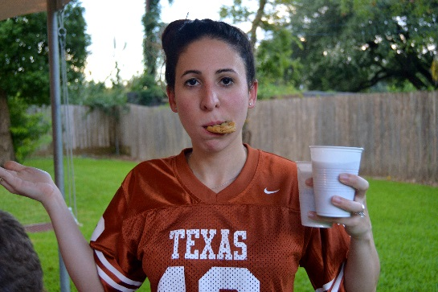
Acadian Bakery: 604 W. Alabama. Awesome cakes! This is a really great bakery! http://acadianbakers.com/ $
Andre’s Pastry Shop & Café: 2515 River Oaks Blvd. & 1101-11 Uptown Park Blvd. Try the mango mousse cake and apricot pastries! Belgian/ French bakery; also open for lunch. $
Common Bond Café & Bakery 1706 Westheimer Rd. commonbondcafe.com $-$$
Moeller’s Bakery: 4201 Bellaire Blvd. Cheap and really good- huge variety of cookies and good cakes- known for their petit fours. $
Petite Sweets: 2700 W Alabama http://www.petitesweetshouston.com/ $$
Rustika Café & Bakery 3237 Southwest Fwy: Cakes are beautiful and very fancy! www.rustikacafe.com $
Tiff’s Treats: multiple locations. https://www.cookiedelivery.com/ $$
Tout Suite: 2001 Commerce St. Coffee, food, cupcakes, macarons in a former mechanic garage that has been converted into a loft-style spacious venue. Great place to study too. http://www.toutsuite.co/ $$

Barbeque:
Gatlin’s Bar Bq: 1221 W. 19th St., www.gatlinsbbq.com $
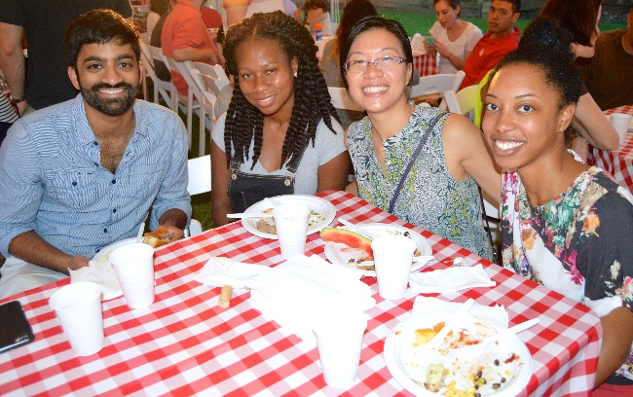
Goode Company: 5109 Kirby Drive. Eat like a Texan- brisket, sausage, and ribs galore! Their jalapeno bread is delicious. http://www.goodecompany.com $
Demeris Barbeque: 2911 S. Shepherd Dr. http://www.demeris.com $

Breakfast:
Avalon Diner: 2417 Westheimer Rd. http://avalondiner.com $
Baba Yega: 2607 Grant St. Nice Sunday brunch, lots of veggie options! www.babayega.com $
Baby Barnaby’s: 602 Fairview http://www.barnabyscafe.com $
Breakfast Klub: 3711 Travis Street. Famous dishes include Katfish & Grits; Wings & Waffles. Get there early- this is a Houston MUST and the line gets long! http://thebreakfastklub.com $
Buffalo Grille: 3116 Bissonnet St. Pancakes the size of your head! http://www.thebuffalogrille.com $
House of Pies: 3112 Kirby Dr. & 6412 Westheimer Road. Awesome place for breakfast, which is served 24 hours/ day. They also have amazing pie and diner food! http://www.houseofpies.com $
Le Peep: 6128 Village Parkway. Standard breakfast menu- really good eggs benedict! Multiple locations including the rice village. http://www.lepeep.com $
Snooze, an A.M. Eatery: 3217 Montrose Blvd #100. snoozeeatery.com $
Churrascos: 2055 Westheimer @ Shepherd Houston, Texas 77098. Great Sunday brunch and great mimosas! https://www.cordua.com/churrascos $$$

Cajun:
Boudreaux’s Cajun Kitchen: 5475 West Loop S. http://www.boudreauxs.net $
Brennan’s of Houston: 3300 Smith Street. Beautiful patio and delicious Cajun food! The Sunday brunch is a must! Very nice restaurant! www.brennansofhouston.com $$$
Rajin’ Cajun: 4302 Richmond Ave. www.rajin-cajun.com $

Chinese:
Panda Garden: 5534 Weslayan. www.pandagarden.com $
Fung’s Kitchen: 7320 Southwest Fwy. #115
http://eatatfungs.com $$
Hong Kong Food Street: 9750 Bellaire Blvd. http://www.hongkong-foodstreet.com $$
Also- check out Chinatown at 59S and Bellaire/Gessner- tons of great restaurants and shopping.

Cuban:
Café Piquet: 5711 Bissonnet St. If you’re feeling Miami, head here to get your plantain fix! You’ll think you’re in little Havana! $$
El Meson: 2425 University Blvd. Great Cuban restaurant in Rice Village- awesome margaritas! $$

French:
Café Rabelais: 2442 Times Blvd. http://www.caferabelais.com $$
Croissant-Brioche: 2435 Rice Blvd. Nice café for a cup of coffee and pastry or sandwich and French onion soup for lunch, in the rice village $
Etoile Cuisine Et Bar: 1101 Uptown Park Blvd, etoilecuisine.com, $$$ (for special occasions)

German:
Rudi Lechner’s: 2503 S. Gessner Road. We love to go here for special occasions. Awesome food and live Oompah band Wed-Sat. nights! A must try!! http://www.rudilechners.com $$

Greek/ Mediterranean:
Aladdin’s: 912 Westheimer Rd $$
Fadi’s Mediterranean Grill: 8383 Westheimer Road http://www.fadiscuisine.com $
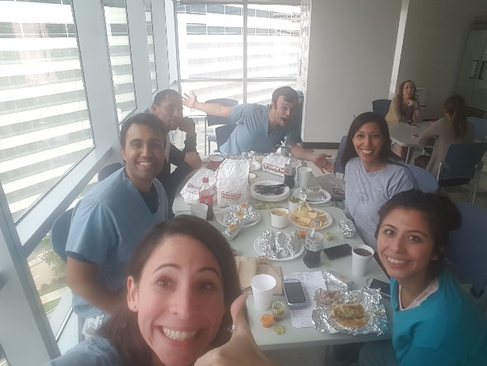
Maryz’s Mediterranean Cuisine: 5825 Richmond Ave. Awesome Lebanese food. Great outside patio and hookahs with all kinds of flavored tobacco. Cheap! http://www.maryzcuisine.com $
Niko Niko’s: 2520 Montrose Blvd. Good for sit down or take out! Probably the most popular Greek restaurant in Houston. Get the gyros, fries or saffron potatoes! http://www.nikonikos.com $
Roadster Grill: 5210 Bissonnet St., Bellaire TX, 77401Has Authentic Greek Family Favorites

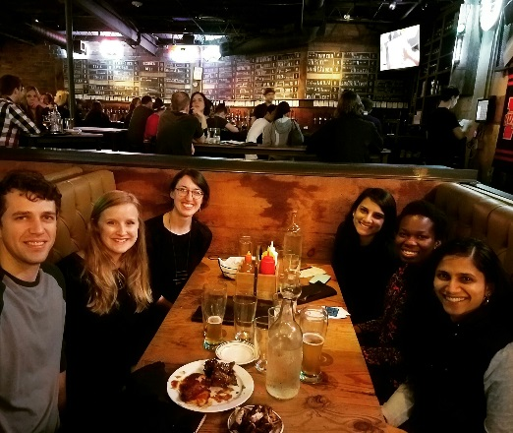
Indian:
Indika: 515 Westheimer Road. Trendy, Indian fusion. http://indikausa.com/indikausa/index.htm $$
Himalaya Restaurant: (Anthony Bourdain ate here) 6652 Southwest Fwy, $$
Khyber Restaurant: 2510 Richmond Ave. $$
Madras Pavilion: 3910 Kirby Dr. Vegetarian. http://www.madraspavilion.us $
Pondicheri: 2800 Kirby Dr, Suite b132, pondichericafe.com, $$
Shiva: 2514 Times Blvd. http://www.shivarestaurant.com $

Italian/ Pizza:
Buon Appetito: 2231 W. Holcombe. Sicilian food. (713) 665-4601 $
Center Court Pizza & Brew: 9721 Broadway St. #101, Pearland, TX $
Collina’s Italian Café: 502 W. 19th St. www.collinas.com $
Copa Ostteria: 5210 Morningside Dr. $$
D’Amico Italian Market Café: 5510 Morningside Dr. #140 www.damico-cafe.com $
Dolce Vita: 500 Westheimer Rd. Upscale Pizzeria www.dolcevitahouston.com $$
Fred’s Italian Corner: 2278 W. Holcombe (Medical Center) http://www.eatatfreds.com Excellent service and food and great prices $
Maggiano’s Little Italy: 2019 Post Oak Blvd. www.maggianos.com $$
Michaelangelo’s: 307 Westheimer Road. Amazing restaurant- great food and atmosphere. http://www.michelangelosrestaurant.com $$
Pronto Cucinino: 1401 Montrose Blvd. http://pronto-2-go.com $
Star Pizza: 2111 Norfolk. Homemade yummy pizza with fresh toppings, bring the kids! http://starpizza.net $
Two Guys Pizzeria: 2250 W. Holcombe Blvd http://www.twoguyspizzeria.net $

Japanese:
Benihana: 1318 Louisiana St. www.benihana.com $$
Uchi: 904 Westheimer. Unbelievably delicious contemporary Japanese cuisine. Trendy date night place! Happy hour has more reasonable prices. $$$$
Kubo’s: 2414 University Blvd. www.kubos-sushi.com $$
Miyako: 3910 Kirby Drive. Good happy hour deals, great variety of sushi, various dining options including large sushi bar and traditional Japanese seating. www.miyakosushibar.com $-$$$
Osaka: 515 Westheimer Road. (713) 533-9098 $
Sushi King: 3401 Kirby Drive. www.sushiking.us $
Sushi Rock: 2400 W. Holcombe Blvd. (713) 667-7625 $
Uptown Sushi: 1131 Uptown Park Blvd. #14. Wear your trendy clothes for the trendy scene! www.uptown-sushi. com $$$
Zake: 2946 S. Shepherd Drive. www.zakehouston.com $$

Jewish:
Kenny and Ziggy’s: 2327 Post Oak Blvd, Houston, TX 77056 · (713) 871-8883 http://www.kennyandziggys.com $$$
New York Bagel Shop: 9720 Hillcroft St (713) 723-5879 713-723-5879 $
Rustika Café & Bakery: 3237 Southwest Fwy (713) 665-6226 www.rustikacafe.com $
Three Brother’s Bakery: 4036 S Braeswood Blvd (713) 666-2253 www.3brothersbakery.com

Mexican/ Texmex/ Burritos:
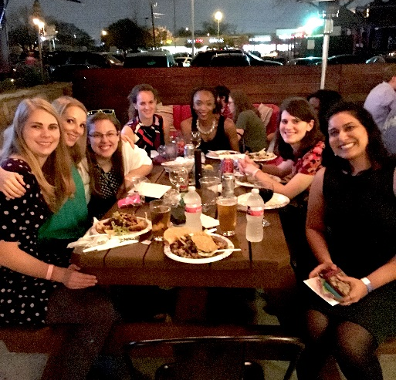
100% Taquito: 3245 Southwest Fwy. 713-665-2900. www.100taquito.com $
Bodega’s: 1200 Binz Dr. www.bodegastacoshop.com $
Chuy’s: 2706 Westheimer Road. Houston staple, make sure to ask for a side of the creamy jalapeno dressing for your chips! 713-524-1700. www.chuys.com $
Cyclone Anaya’s Mexican Kitchen: 309 Gray St. Take margaritas one at a time. 713-520-6969. www.cycloneanaya.com $$
El Pueblito Place: 1423 Richmond Ave. Lots of seafood.713-520-6635. http://elpueblitopatio.com $
Escalante’s: 4053 Westheimer Rd. 713-623-4200. http://www.escalantes.net $
Hugo’s: 1602 Westheimer Road. Fancy! 713-524-7744. www.hugosrestaurant.net $$$
La Tapatia Taqueria: 1749 Richmond Ave. Affordable, good taqueria, good margaritas. 713-521-3144. http://latapatiahouston.com $
Lupe Tortilla: 2414 Southwest Fwy. Brilliant! Adults drink margaritas while the kids are in the sandbox, great fajitas. 713-522-4420. www.lupetortillas.com $
Mission Burrito: 2245 W. Alabama St. 713-529-0535. www.missionburritos.com $
Ninfas: The original Ninfas on Navigation is thought to be the best of all the franchises, a Houston classic! If you want fajitas, go to Ninfas. www.ninfas.com $$
Pappasitos: all over! Yelp the location nearest you. $$
Picos: 3601 Kirby Dr. Best place for margaritas! www.picos.net $$
Teala’s Mexican Restaurant: 3210 W. Dallas St. 713-520-9292. http://tealas.com
Torchy’s Tacos: 2411 S. Shephard Dr. www.torchystacos.com
Velvet Taco: innovative tacos (shrimp & grits, ahi poke tuna, falafel, etc.) and thai red curry queso. 4819 Washington Ave. http://www.velvettaco.com/houston $

Nice & Fancy!:
Café Annie: 1728 Post Oak Blvd. 713-840-1111 www.cafe-annie.com $$$
Caracol: a restaurant that bills itself as “Coastal Mexican” with an all-you-can-eat Sunday brunch (ceviche, filet mignon, dessert) that also includes a raw oyster bar for $35/pp. Excellent for Sunday brunch. 2200 Post Oak Blvd #160. http://www.caracol.net/ $$
Mark’s American Cuisine: 1658 Westheimer Road. Fine dining in a converted church! Save up for an anniversary or birthday! 713-523-3800 www.marks1658.com $$$$
Ruggles Black: 3963 Kirby Dr. Provides Paleo options. http://www.rugglesblack.com
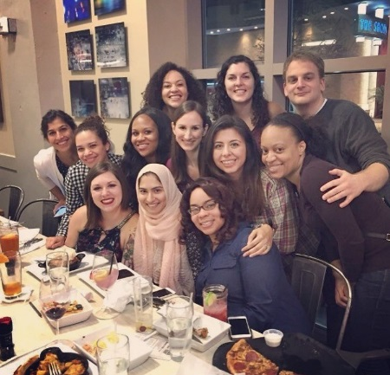
Ruggles Grill: 903 Westheimer Road. 713-524-3839. www.rugglesgrill.com

Seafood:
Good Company Seafood: 2621 Westpark Dr. 713-523-7154 $$$
Little Pappa’s Seafood: 3001 S. Shepherd Dr. 713-873-1121 www.pappasseafood.com $$
Reef: 2600 Travis Street. 713-526-8282, great reviews in Food & Wine Magazine, The New York Times, and many others, Modern. www.reefhouston.com $$$

South American:
America’s Restaurant: 1800 Post Oak Blvd. 713-961-1492. www.cordua.com $$$
Churrasco’s: 2055 Westheimer Road. Awesome steaks. The tres leches is thought to be one of the best in Houston. 713-527-8300. www.cordua.com $$$
Seco’s Latin Cuisine: 2536 Nottingham Street. Awesome Sunday brunch. I love this little restaurant! 713-942-0001. $-$$

Steakhouse:
III Forks: 1201 San Jacinto. 713- 658-9457. www.iiiforks.com $$$
B&B Butchers: 1814 Washington avenue www.bbbutchers.com $$$
Capital Grille: 5365 Westheimer Road. 713-623-4600 www.thecapitalgrill.com $$$$
Killen’s Steakhouse: 2804 S. Main Street, Pearland, TX 281-485-0844. www.killenssteakhouse.com $$$$$
Pappas Bros. Steakhouse: 5839 Westheimer Road. 713-780-7352. http://www.pappasbros.com/home $$$$
Ruth’s Chris Steak House: 6123 Richmond Ave. 713-789-2333. www.ruthschris.com $$$$
Taste of Texas Restaurant: 10505 Katy Fwy. 713-932-6901. www.tasteoftexas.com $$$-$$$$
Vic & Anthony’s Steakhouse: 1510 Texas St. 713-228-1111 www.vicandanthonys.com $$$$

Thai:
Morningside Thai Café: 6710 Morningside Drive. 713-661-4400. www.morningsidethai.com $$
Nidda Thai Cuisine: 1226 Westheimer Road. 713-522-8895 $
Nit Noi: Multiple locations, www.nitnoithai.com $
Patu: 2429 Rice Blvd. 713-6998. $$
Thai Gourmet: 6324 Richmond Ave www.thaigourmethouston.com $$
Thai Spice: 5117 Kelvin Drive. Nice, cheap lunch buffet. 713-522-5100 www.thaispice.com $
Thai Sticks: 4319 Montrose Blvd. Awesome Thai food. Great atmosphere. Love it! 713- 529-4500. $$

Turkish:
Istanbul Grill: 5613 Morningside Dr. 713-526-2800 http://www.istanbulgrill.com $
Pasha: 2325 University Blvd. 713-592-0200. www.epasha.com $$
Turquoise Grill: 3701 Kirby Drive. Awesome Turkish food. 713-526-3800. www.tghouston.com $-$$

Vegetarian:
Field of Greens: 2330 W. Alabama St. 713-533-0029 www.fieldofgreenshouston.com $
Hobbit Café: (non veggie options as well!) 2243 Richmond Ave. 713-528-3418 www.thehobbitcafe.com $

Vietnamese:
Nam Noodles: 2512 Smith Ranch Rd (they deliver!)
Mai’s Restaurant: 3404 Milam Street. 713-520-7684 www.maistrestauranttx.com $
Pho Dien: 10623 Bellaire Blvd, 832-328-1866 www.phodienhouston.com
Pho Ga Dakao: 11778 Bellaire Blvd, 281-879-5899 www.phogahouston.com
Pho Saigon Noodle House: 2808 Milam St. 713-524-3734. www.phosaigonnoodlehouse.com $
Van Loc Restaurant: 3010 Milam St. 713-528-6441. www.vanlocrestaurant.com
Vietopia: 5176 Buffalo Speedway. 713-664-7303
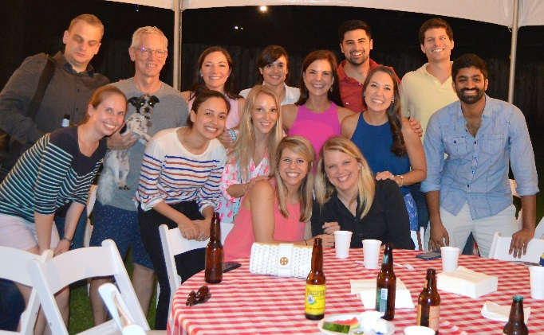
Other Recommendations:
Jenni’s noodle House: 3111 S. Shepherd Dr. www.noodlesrule.com
Les Givral’s Kahve: Vietnamese Sandwiches on Milan N. of Elgin
Papa’s Restaurants: Steakhouse, tex-mex, seafood- multiple locations
Pei Wei Asian Diner: 5110 Buffalo Speedway www.peiwei.com
Tex- Chick: 712 ½ Fairview St. 713-528-4708.
Yao Restaurants & Bar: 9755 Westheimer Road. www.yaorestaurant.com
***Go to Buca Di Beppo (http://www.bucadibeppo.com)on Buffalo Speedway then walk down to Pacuigo’s for homemade gelato: (http://paciugo.com)***
~Happy Hours~
Aka Sushi: 2390 W. Alabama St, 713-807-7875, www.akasushi.net
Amazon Grill: 5114 Kirby Drive, 713-522-5888, www.cordua.com, Mon-F 4-7pm $2.50 drinks
Benjy’s: 2424 Dunstan St. Every night 4-7pm $5.00 drinks (great blue-cheese stuff olive martinis) and $6.00 appetizers (great food!) –nicer lounge atmosphere. www.benjys.com
Baker Street Pub & Grill: 5510 Morningside Dr, 713-942-9900, Mon-Sat 209pm, All day Sunday: $1.75 domestics and wells. www.sherlockspubco.com
Front Porch Pub: 217 Gray, 713-571-9571, www.frontporchpub.com
Little Woodrow’s: multiple locations- Rice Village & Midtown Mon-F until 7pm check out site for daily specials. www.littlewoodrows.com
Mi Luna Tapas Restaurant: 2441 University Blvd, 713-520-5025 www.mi-luna.com Mon-F 3-7 PM $3 sangria and tapas
RA Sushi: 3908 Westheimer Rd, 713-621-5800, www.rashushi.com
Taco Milagro: 2555 Kirby Dr, 713-522-1999, www.taco-milagro.com, M-F 4-7pm, $3.50 margaritas, $1.00 off beers
The Ginger Man: 5607 Morningside Dr. 713-526-2770, www.gingermanpub.com
Zake Japanese Restaurant: 2946 S. Shepherd Dr, 713-526-6888, www.zakehouston.com M-F 5-7: $1.75 Zake Bombs, $2 domestics, $2.50-3.50 appetizers.
Additional Information can be found on this blog: www.crazyhappyhour.com

Wine Bars
Cru A Wine Bar: 2800 Kirby Dr www.cruawinebar.com $$
Beckrew: 2409 W Alabama St www.beckrew.com $$
Simone on Sunset: 2418 Sunset Blvd (close to work, great for team happy hours!) $$
The Tasting Room: 1101 Uptown Park www.tastingroomwines.com $$

Breweries
St Arnold’s: great brewery tours, original Houston brewery, lots of young professional happy hours here
8th Wonder Brewery: new brewery in the middle of downtown Houston
Buffalo Bayou Brewery: a little farther out
Karbach Brewery: new beer garden, new restaurant, great place for day drinking Saturdays
~Places to Study ~ Coffee/Tea Shops~

Antone’s Deli: (free wi-fi, tables in/outside) 424 Dunstan Rd. 713-521-2883
Agora: 1712 Westheimer Rd. 713-526-7212
Bacchus: 2520 Dulavy Street. This Montrose wine bar and coffee shop place is awesome! They even have wine and pie nights. Free wi-fi.
Barnes & Noble: (wi-fi, but you have to pay for it) 3003 W. Holcombe Blvd., 713-349-0050
Baylor College of Medicine: (yes…it is a school…but if you seriously need to get some work done, there is a brand new area on the 2nd, 3rd and 4th floors of the main Baylor building with tons of tables, desks, couches- and wi-fi)
Black Hole Coffee: 4504 Graustark St, 713-528-0653, www.blackholecoffeehouse.com
Black Walnut: (Rice Village, free wi-fi, big tables- and gelato) 5510 Morningside Dr.
Brasil: 2604 Dunlavy St. Good coffee, also has food and live music sometimes on the weekend.
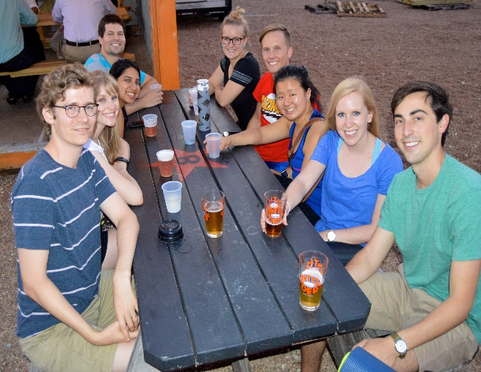
Empire Café: 1732 Westheimer Road. Monday night half price cake night, good coffee! 713-528-5282
Inversion Coffee House: 1953 Montrose Blvd.713-523-4866, http://www.inversioncoffeehouse.com
Nu Café: 9889 Bellaire Blvd, 713-771-7771, nucafehouston.com
Siphon: 701 W Alabama St. http://siphoncoffeehouston.com
Starbucks: Everywhere!
Taft: 2115 Taft St. free wi-fi, big tables. 713-522-3533. www.2115taft.org
Tapioca Express: 3311 Westpark Dr. Free wi-fi, tapioca milk tea. 713-668-7778. www.tapiocaexpress.com
Teahouse: 2089 Westheimer Road. 713-526-6123. Free wi-fi and tapioca milk tea. www.teahousebeverage.com
Tropioca: 2808 Milam St. #G. Free wi-fi, big tables, tapioca milk tea. 713-373-7111. www.tropioca.com
~Ice Cream~

Amy’s Ice Cream: 3816 Farnham St. 713-526-8697 Fun, eclectic flavors, good mix-ins. www.amysicecreams.com
Baskin Robins: on University (Rice Village) www.baskinrobbins.com
Ben and Jerry’s: 5515 Kirby Dr (Rice village) www.benjerry.com
Black Walnut: Gelato in Rice Village, 5510 Morningside Drive, www.blackwalnutcafe.com
Chocolate Bar: 2521 University Blvd, everything is chocolate- tons of ice cream, chocolate coffee. 713-520-8599. www.theoriginalchocolatebar.com
Cloud 10 Creamery: 5216 Morningside Dr, 713-434-6129, www.cloud10creamery.com
Fat Cat Creamery: 1901 N Shepherd Dr. #3, fatcatcreamery.com
Hank’s Ice Cream: 9291 S. Main St. 713-665-5103. www.hanksicecream.com
Marble Slab: 3175 W Holcombe Blvd, www.marbleslab.com
Paciugo Gelato: 5172 Buffalo Speedway, This place has amazing gelato! 713-666-4958, www.paciugo.com

~Places that Deliver Food to the Medical Center:~

So you want to celebrate on call by eating something other than McDonalds or St. Luke’s Cafeteria? Here are some frequented venues for on call diners. Also, make sure to ask the nurses as well- each team has a book of lots of menus from places that deliver.

Fuzzy’s Pizza: 5925 Kirby Dr. Suite N. 713-522-6677, www.fuzzyspizzahouston.com
Hunan’s: 3835 Bellaire Blvd. Awesome food and they are fast! 713-666-2000
Hungry’s: 2356 Rice Blvd. 713-523-8652, www.hungryscafe.com
Jason’s Deli: 2530 University Blvd. 713-523-8652, www.hungryscafe.com
Jimmy John’s: 2401 A. W. Holcombe Blvd. 713-741-0600, www.jimmyjohns.com
Star Pizza: Delivers to TCH, but not BT. 2111 Norfolk, 713-523-0800, www.starpizza.net
The Chocolate Bar: 2521 University Blvd, 713-520-8888, www.theoriginalchocolatebar.com
Thai Village: 2512 Times Blvd. 713-524-8682, www.thaivillagehouston.com
Qin Dynasty: 5115 Buffalo Speedway #900. 713-660-8386, www.qindynasty.biz

UberEats, Door Dash, Favor, & PostMates are also great options to delivery to the hospital from dozens of local restaurants!
~BCM Employee Discounts:~
Please refer to BCM Intranet > Human Resources > Benefits > Work Life

Child Care: Discounted back-up date care, discounts on activities including Gymboree
Entertainment: 10% discount for the Houston Grand Opera, monthly discounts for the performing arts
Housing: Discounts with real estate companies including Century 21, Perry Homes, and various moving companies.
Services: Discounts for some dentists, chiropractors
Tuition Assistance: Receive up to $2,000 tax free per year towards tuition-related fees; eligibility requirements apply
Wellness:
24 Hour Fitness: No enrollment fees and monthly discounts; Lifetime Fitness: Discounted enrollment; Curves: No enrollment fees (some locations) and monthly discounts; plus discounts at the BCM and UT Rec Centers, Weight Watchers: 20% Discount
***For more discounts visit the TCH and BCM Employee Discount Pages***

~Come Visit the House Staff Office Often~

There are many wonderful people in the house staff office you should get to know! The office is generally open from 7am-5:30pm. Always feel free to stop by the office to chat.

Program Director:
Dr. Mark Ward
Dr. Ward is ALWAYS available and supportive!

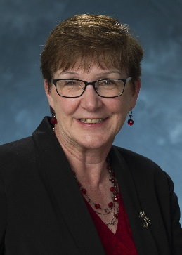
Academic Administrator:
Melodie Allison
Melodie keeps the whole department going! We really appreciate everything Melodie does for us! She knows all the rules and is the one to work out recruitment, finance, sick leave, among many other things.

Coordinators:
We are always willing to help you with whatever you need including Notary for official documents! We can’t wait to get to know all of you!!
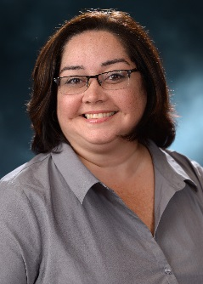
Maria J. Torres
Maria, handles everything Global Health and is a Notary
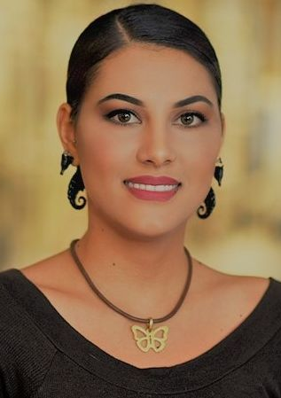

Britney May Mortenson
Britney May, handles everything Lead and Acquire and Residency Verifications

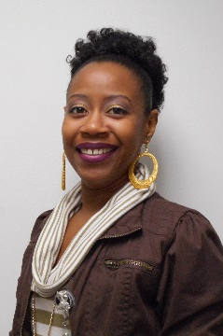

Tasha Wilkes
Tasha, handles everything related to food, societies, E-value and is a Notary.

Meet your Associate Program Directors~
All of our APDs are always willing to meet with residents and are very supportive.

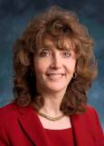


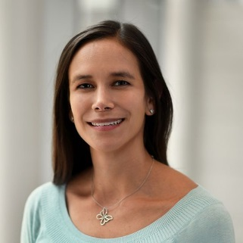
Dr. Turner (Vice Chair of Education and Associate Program Director):
Dr. Turner’s office is located on the 15th floor of the CCC if you’d like to meet with or visit her.
Department: Academic General Pediatrics

Dr. Acosta:
Dr. Acosta’s office is located on the 2nd floor of the Feigin Center if you’d like to meet with or visit her.
Department: Renal

Dr. Gillespie:
Dr. Gillespie’s office is located on the 6th floor of the Feigin Center if you’d like to meet with or visit her.
Department: Retrovirology and Global Health

Dr. Hsu:
Dr. Hsu’s office is located on the 2nd floor of the Abercrombie Building if you’d like to meet with or visit her.
Department: Emergency Medicine

The chiefs always have candy in the office- so please stop by!!!
The door is always open!
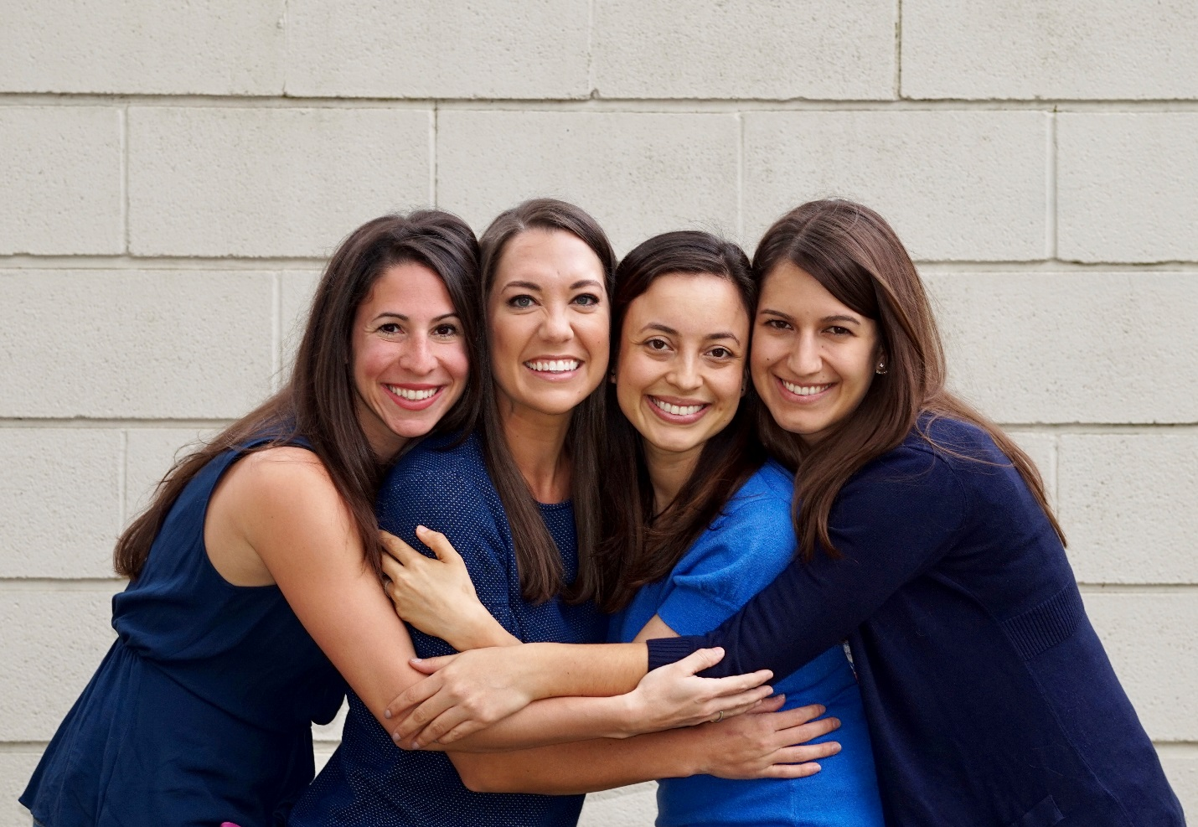

Helpful Websites:
- The BCM Website: https://www.bcm.edu/departments/pediatrics/education/pediatric-residency-program
- The Med-Peds website: http://www.bcm.edu/medpeds/

